**Machine Learning Course Notes**

**Examples of machine learning -**

* Database mining (Click stream analysis, medical records)
* Applications (Handwriting recognition, NLP, Computer Vision)
* Self-Customizing programs (Amazon for customizing product ads etc)

**2 types -**

* Supervised Learning :- We are given a data set & already know what our correct output should look like, having the idea that there is a relationship between I/p and O/p
* Unsupervised Learning :- Creating clusters or approaching towards output without knowing the exact output. Define unsupervised learning as problem where we are not told what the desired output is.

**2 types supervised learning**

* Regression problem - Predict results within a continuous o/p. Map input variables to some continuous function
* Classification problem - Map input variables into discrete categories

**2 types of unsupervised learning**

* Clustering Example :- Given set of news articles found on web, group them into set of articles of the same story
* Non-Clustering Example :- Cocktail party algorithm - Separates out 2 different voice streams received by a single microphone.

**Linear Regression hypothesis** -

h*θ*(x) = *θ0 + θ1.x is the form of any linear regression hypothesis. Now our role is to find out the values of θ0 and θ1*

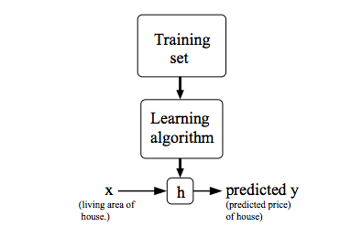

*x*(*i*) to denote the “input” variables also called input features and

*y*(*i*) to denote the “output” or target variable that we are trying to predict

A pair (*x*(*i*),*y*(*i*)) is called a training example

A list of m training examples (*x*(*i*),*y*(*i*)); where i=1,...,m—is called a training set

* Our goal is, given a training set, to learn a function h : X → Y so that h(x) is a “good” predictor for the corresponding value of y. For historical reasons, this function h is called a hypothesis.

**Cost Function - Intuition 1 (When Theta0 is fixed)**

* We can measure the accuracy of our hypothesis function by using a cost function.

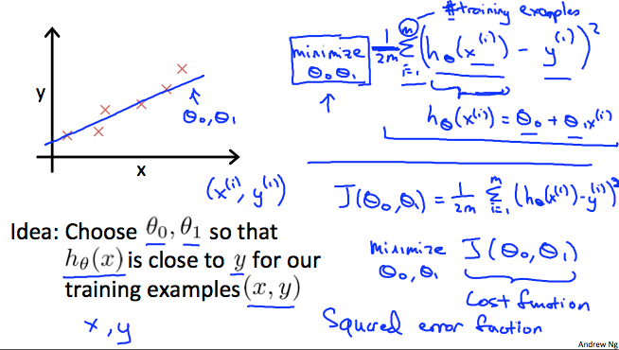

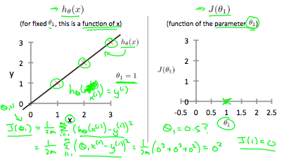

When *θ*1=1, we get a slope of 1 which goes through every single data point in our model. Conversely, when *θ*1=0.5, we see the vertical distance from our fit to the data points increase.

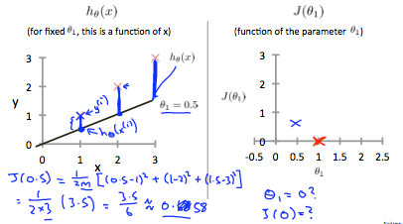

This increases our cost function to 0.58. Plotting several other points yields to the following graph: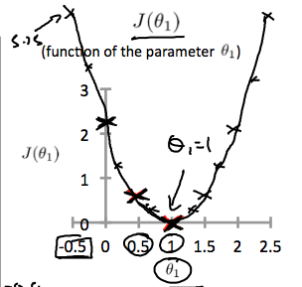

Thus as a goal, we should try to minimize the cost function. In this case, *θ*1=1 is our global minimum.

In general -

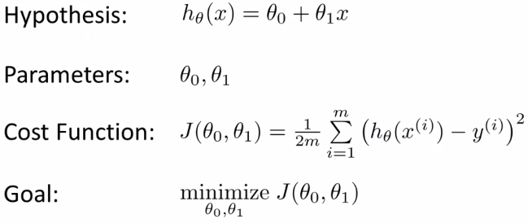

# **Cost Function - Intuition II (when 2 variables are there)**

A contour plot is a graph that contains many contour lines. A contour line of a two variable function has a constant value at all points of the same line

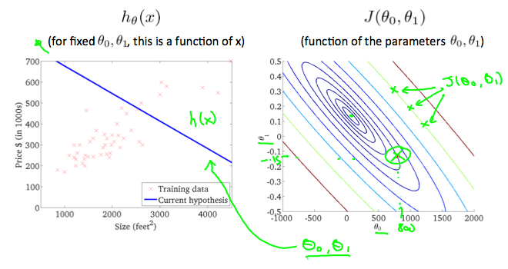

At the centre of the contour graph, we get minimum cost and that gives us the right value of theta0 and theta1.

Theta0 and theta1 are nothing but the constants in linear regression function.

**The gradient descent algorithm:** The algorithm helps to find the optimum value of Theta1 and Theta0 so that the cost function is minimum. This algorithm is as below.

repeat until convergence(cost function = minimum):

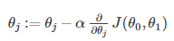

where, j=0,1 represents the feature index number.

Derivative is nothing but the slope of the tangent drawn on the cost function graph at a particular point.

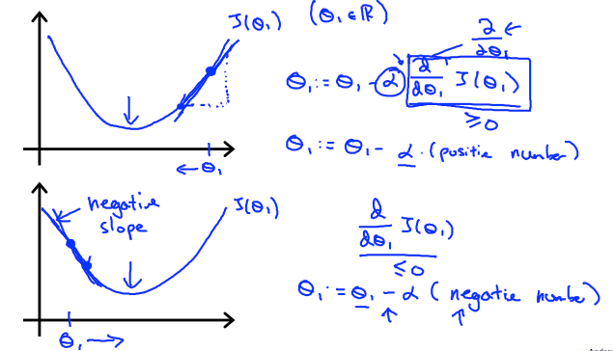

At convergence, or at the point where the cost of function is minimum, the derivative term or the slope of the tangent is 0, so theta does not change.

**Multiple Featres - Multi variate Linear regression**

The hypothesis is

*hθ*(*x*)=*θ*0+*θ*1*x*1+*θ*2*x*2+*θ*3*x*3+⋯+*θnxn*

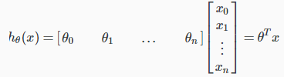

Gradient Descent for Multi variate linear regression is

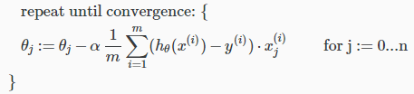

The cost function and Gradient descent for multi-variate linear regression can also be written like this in short form

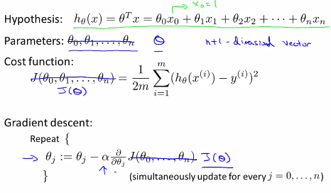

How values of each theta can be calculated for convergence - example

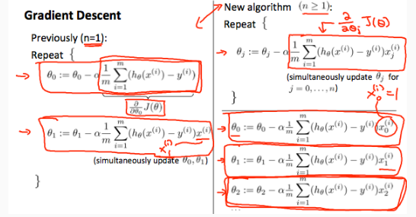

**Practical tip on using Gradient Descent**

We can speed up gradient descent by having each of our input values in roughly the same range. This is because θ will descend quickly on small ranges and slowly on large ranges.The way to do this is to modify the ranges of our input variables so that they are all roughly the same. Ideally:

−1 ≤ x(i) ≤ 1

These aren't exact requirements; we are only trying to speed things up. The goal is to get all input variables into roughly one of these ranges. Two techniques to help with this are **feature scaling** and **mean normalization**.

**Feature scaling** involves dividing the input values by the range (i.e. the maximum value minus the minimum value) of the input variable, resulting in a new range

**Mean Normalization** is

Deducting mean value from each sample, brings the value in the range (-0.5 to 0.5)

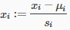Where *μi* is the average of all the values for feature (i) and *si* is the range of values (max - min), or *si* is the standard deviation.Note that dividing by the range, or dividing by the standard deviation, give different results. For example, if *xi* represents housing prices with a range of 100 to 2000 and a mean value of 1000, then, 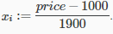

**Another tips for ensuring that gradient descent is working fine**

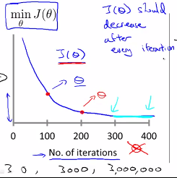 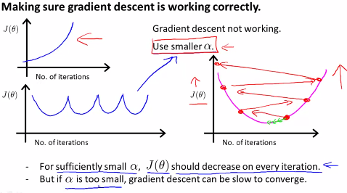

The graph on the left hand side ensures that Gradient descent is working fine and graph on the right hand side shows that it is not working as expected and hence alpha(Learning rate) needs to be smaller.

If Learning rate is too small, then convergence will be slower

If Learning Rate is too large, then cost function may not decrease, it may not converge also

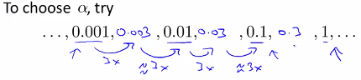

**Improving the models (Polynomial function)**

We can improve our features (x1, x2) and the form of our hypothesis function in a couple different ways.

1. We can combine multiple features into one. For example, we can combine x1 and x2 into a new feature x3 by taking x1⋅x2.
2. Our hypothesis function need not be linear (a straight line) if that does not fit the data well. We can change the behavior or curve of our hypothesis function by making it a quadratic(max square of a variable), cubic or square root function (or any other form). This is done only after identifying all the features and realizing that the curve does not fit the linear model. For example, if our hypothesis function is *hθ*(*x*)=*θ*0+*θ*1*x*1 then we can create additional features based on *x*1, to get the quadratic function **or the cubic function . In the cubic version, we have created new features *x*2 and *x*3 where . One important thing to keep in mind is, if you choose your features this way then feature scaling becomes very important. eg. if *x*1 has range 1 - 1000, then range of ** becomes 1 - 1000000 and that of ** becomes 1 - 1000000000

Generally if it is linear regression then there will be a global minimum value of theta for which the cost function is minimum and convergence happens but there could be cases where gradient descent algorithm can find local optima as well. This depends on the initial assumed value of the theta.

**Alternative to Gradient Descent -> Normal Equation**

It’s method to solve for theta analytically. Gradient descent gives one way of minimizing J. Let’s discuss a second way of doing so, this time performing the minimization explicitly and without resorting to an iterative algorithm

Simplest form -

If there is only one feature and J(theta) is a quadratic equation (which usually is not a case) then calculating the derivative and comparing it with 0, can solve the value for theta.

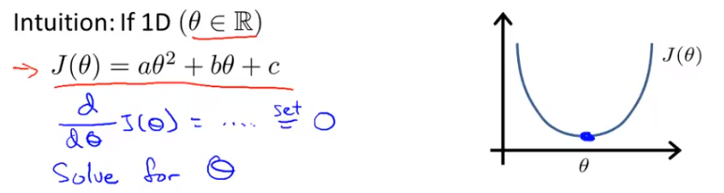

In our cost function -

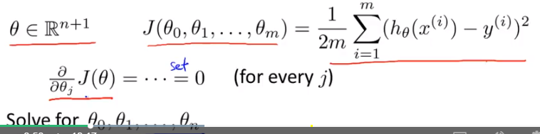

Another way of finding it analytically is through matrix calculation.

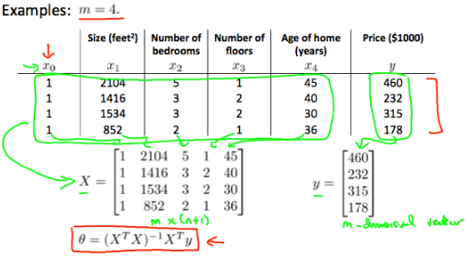

This is the value of Theta (which is a vector of theta) to minimize the cost function J(Theta).

There is **no need to do feature scaling** with the normal equation

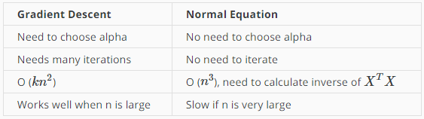

With the normal equation, computing the inversion has complexity O(*n*3). So if we have a very large number of features, the normal equation will be slow. In practice, when n (No. of features) exceeds 10,000 it might be a good time to go from a normal solution to an iterative process.

Gradient Descent is good fit for linear regression with large no of features as well as Logistic regression problem for which normal equation method does not work properly or become inefficient

m = no. of training samples

n = no. of features

x1...n = feature values

Theta1...n = coefficients for each feature

X = as a matrix of all training examples

When implementing the normal equation in octave we want to use the 'pinv' function rather than 'inv.' The 'pinv' function will give you a value of θ even if  is not invertible. If  is noninvertible, the common causes might be having :

* Redundant features, where two features are very closely related (i.e. they are linearly dependent)
* Too many features (e.g. m ≤ n). In this case, delete some features or use "regularization" (to be explained in a later lesson).

**Logistic Regression**

It’s a method used for classification. To attempt classification, one method is to use linear regression and map all predictions greater than 0.5 as a 1 and all less than 0.5 as a 0. However, this method doesn't work well because classification is not actually a linear function.

The classification problem is just like the regression problem, except that the values we now want to predict take on only a small number of discrete values. For the classification problems having binary prediction, can not have output >1 or <0.

For linear regression hypothesis was 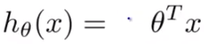Where Theta Transpose is nothing but the values of each theta (parameters) in linear regression.

For Logistic regression, we are going to change hypothesis function as below

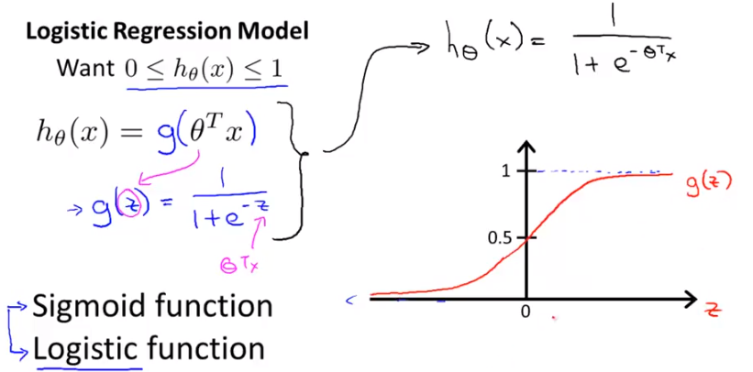

Sigmoid and Logistic function terms can interchangeably used.

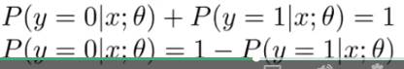

The probability of all the discrete value cumulatively adds to 1.

*hθ*(*x*)≥0.5→*y*=1

*hθ*(*x*)<0.5→*y*=0

*z*=0,*e*0=1⇒*g*(*z*)=½

*z*→∞,*e*−∞→0⇒*g*(*z*)=1

*z*→−∞,*e*∞→∞⇒*g*(*z*)=0

so y will be equal to 1, when g(z) >= 0.5 i.e. when >= 0.5

g(z) is >= 0.5 when z >=0 i.e. when , >= 0

So we can say that, y = 1 when  >=0 or 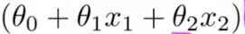 >= 0

As explained in below example if the values of theta0, theta1 and theta2 is -3, 1, 1; for y to be equal to 1, x1 + x2 >= 3

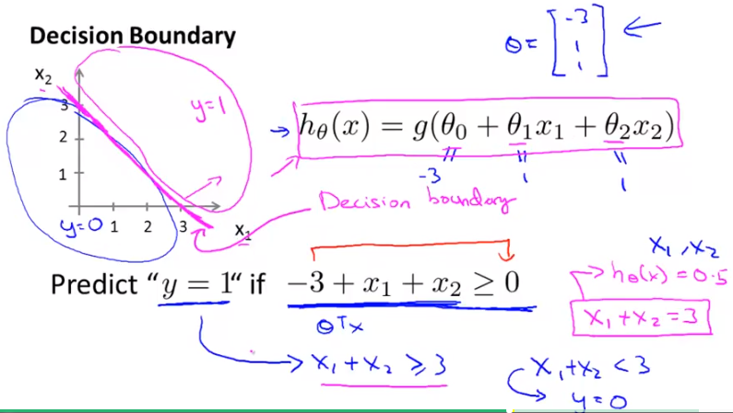

In this example we have assumed that somehow we found values of thetas. How to find the right values of thetas, that we will see later.

The line x1 + x2 >= 3 is called as Decision Boundary. It is the threshold. It can be linear or non linear.

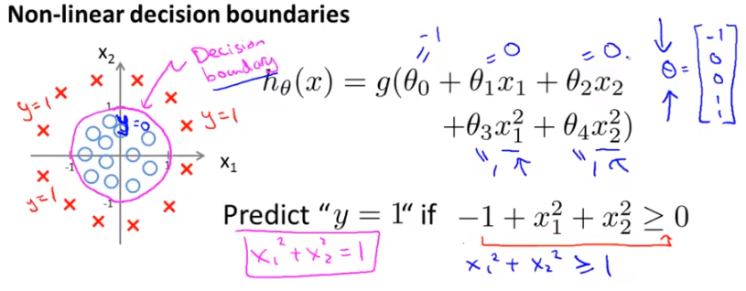

This is the example of non linear hypothesis function, where squared variables are added. Here makes a decision boundary circular cenetered at origin and the parameters decide the radius of this circle.

Decision boundary is a property not of a training set but of hypothesis and parameters (thetas). In above example hypothesis is defining the curve i.e. x1 square + x2 square. And Parameters are the values of thetas. These 2 params make up Decision boundary

**Higher Order Polynomial hypothesis**

The hypothesis can be even larger order and in such cases the decision boundary can become some weird shape.

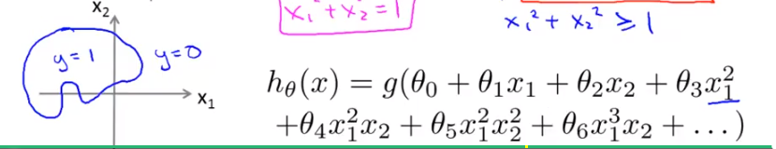

**Cost function**

We cannot use the same cost function that we use for linear regression because the Logistic Function will cause the output to be wavy, causing many local optima. In other words, it will not be a convex function.

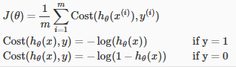

plot for *J*(*θ*) vs *hθ*(*x*):

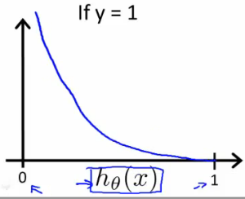 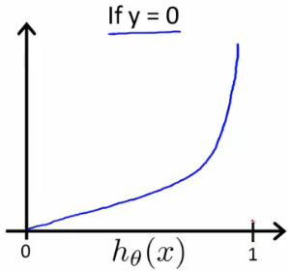

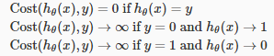

If our correct answer 'y' is 0, then the cost function will be 0 if our hypothesis function also outputs 0. If our hypothesis approaches 1, then the cost function will approach infinity.

If our correct answer 'y' is 1, then the cost function will be 0 if our hypothesis function outputs 1. If our hypothesis approaches 0, then the cost function will approach infinity.

Note that writing the cost function in this way guarantees that J(θ) is convex for logistic regression.

The above mentioned cost function can be shortly mentioned as





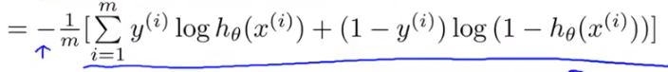

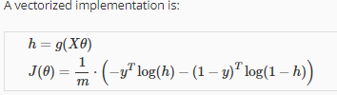

### **Gradient Descent**

the general form of gradient descent is:

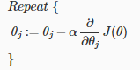

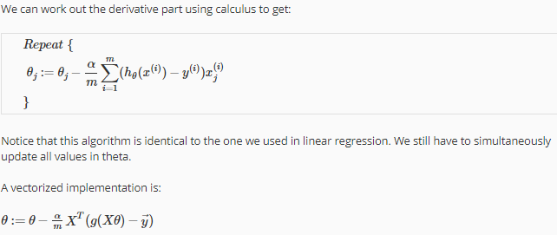

Gradient Descent algorithm is still same whether we apply it for logistic regression or linear regression. The only param that varies is the hypothesis in each of these 2 cases.

If required feature scaling can be used for gradient descent in logistic regression.

**Advanced Optimization for Logistic regression**

"Conjugate gradient", "BFGS", and "L-BFGS" are more sophisticated, faster ways to optimize θ that can be used instead of gradient descent. We suggest that you should not write these more sophisticated algorithms yourself (unless you are an expert in numerical computing) but use the

libraries instead, as they're already tested and highly optimized. Octave provides them.

To use advanced library to calculate gradient descent, this is how it can be done in Octave.

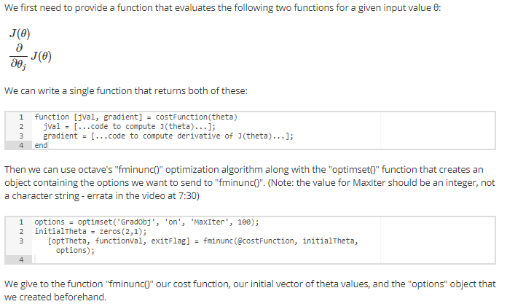

# Multiclass Classification: One-vs-all

Now we will approach the classification of data when we have more than two categories. Instead of y = {0,1} we will expand our definition so that y = {0,1...n}.

Since y = {0,1...n}, we divide our problem into n+1 (+1 because the index starts at 0) binary classification problems; in each one, we predict the probability that 'y' is a member of one of our classes.

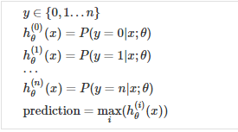

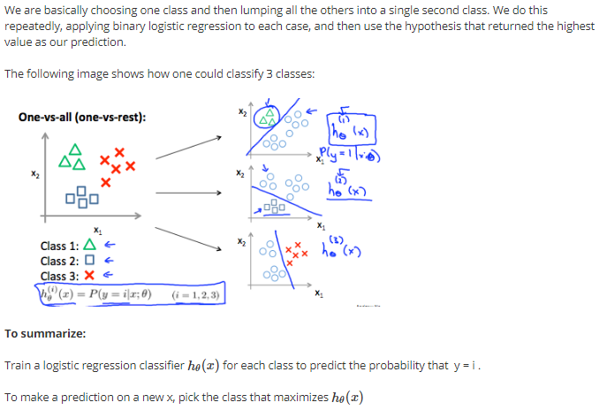

**Underfit and Overfit**

In following both the examples of linear regression and logistic regression, if hypothesis is not well designed then many a points are not rightly predicted and that is called underfit. Whereas overfit is something where hypothesis predicts right for all inputs of the training set but it may not work for new points.

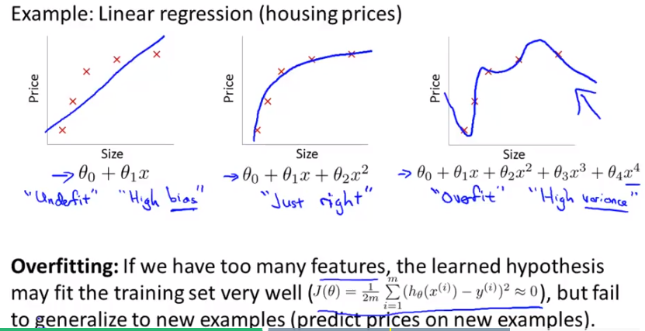

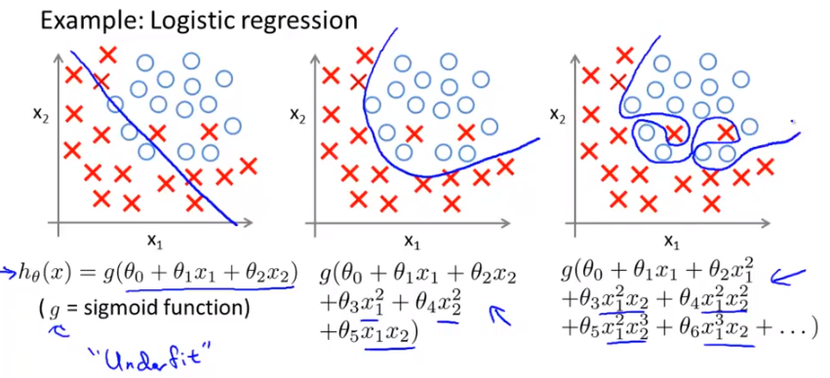

Over fitting can happen if there are not enough training data and there are more features. To solve overfitting there are 2 options

1) Reduce the number of features:

* Manually select which features to keep.
* Use a model selection algorithm (studied later in the course).

2) Regularization

* Keep all the features, but reduce the magnitude of parameters *θj*.
* Regularization works well when we have a lot of slightly useful features.

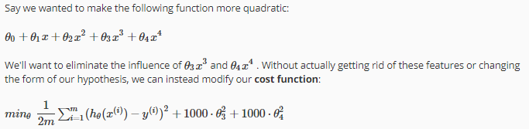

We've added two extra terms at the end to inflate the cost of *θ*3 and *θ*4. Now, in order for the cost function to get close to zero, we will have to reduce the values of *θ*3 and *θ*4 to near zero. This will in turn greatly reduce the values of *θ*3*x*3 and *θ*4*x*4 in our hypothesis function. As a result, we see that the new hypothesis (depicted by the pink curve) looks like a quadratic function but fits the data better due to the extra small terms *θ*3*x*3 and *θ*4*x*4.

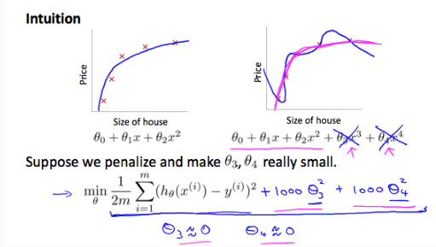

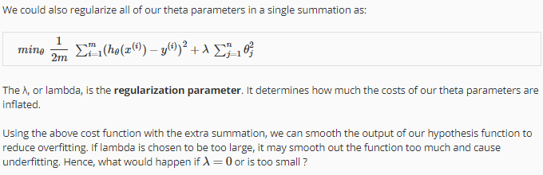

We can apply regularization to both linear regression and logistic regression. Earlier we applied the regularization to cost function and now we will apply it to gradient descent.

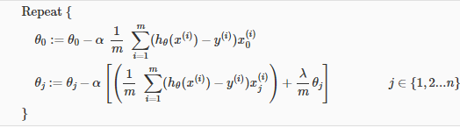

We will not penalize theta0 as it is a constant.

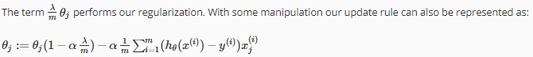

The first term in the above equation, 1−*αλm* will always be less than 1. Intuitively you can see it as reducing the value of *θj* by some amount on every update. Notice that the second term is now exactly the same as it was before.

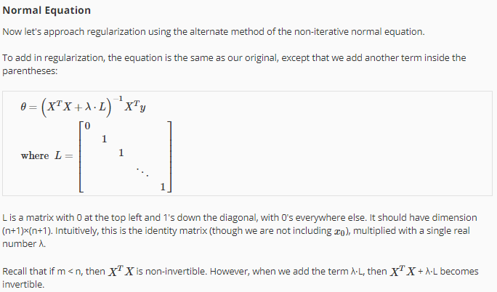

**Regularized Logistic Regression**

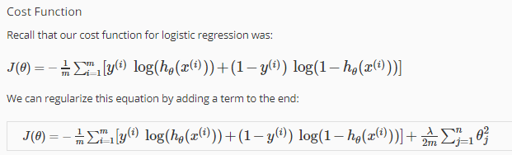

This is how regularized logistic regression can be calculated using advancedalgorithm library provided by Octave

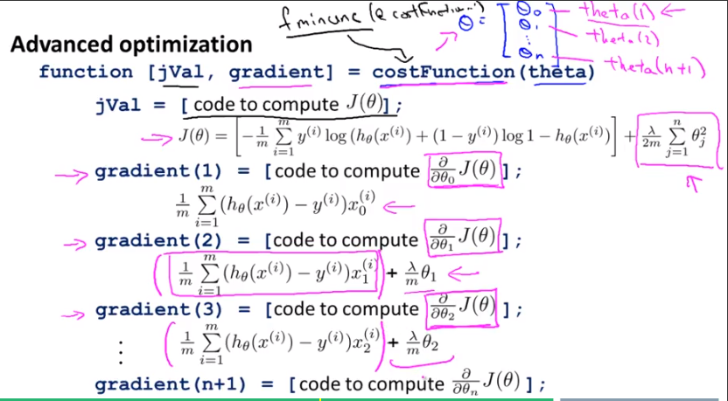

**Neural network**

If the no. of variables are too much and the hypothesis needs to be made nonlinear, then we may include square and cube terms also (2nd order and 3rd order terms also) in the polynomial hypothesis. This may cause the no. of features to grow exponentially and it becomes impossible to develop algorithm using gradient descent or normal eq. So we have to resort to neural network.

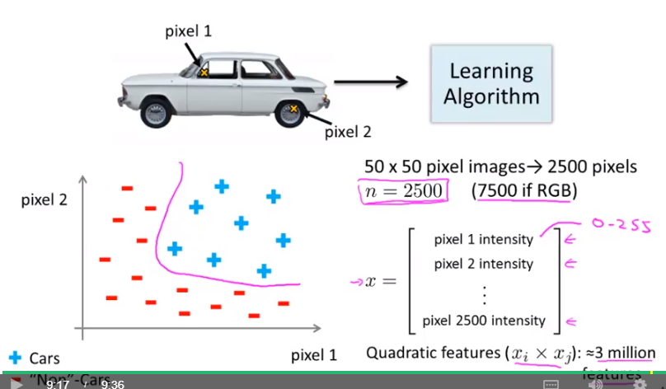

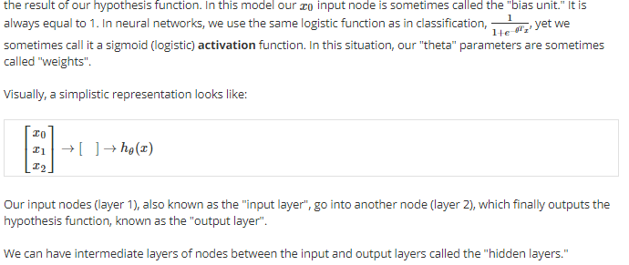

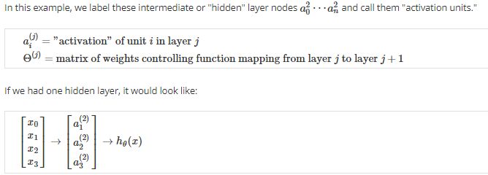

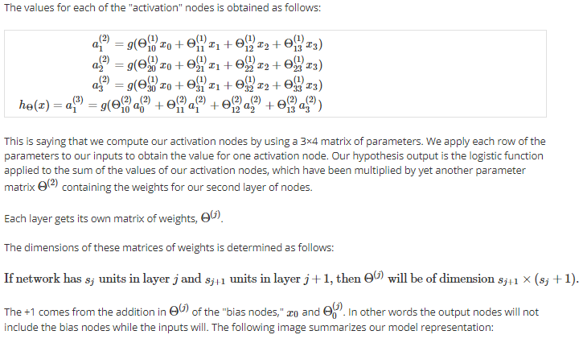

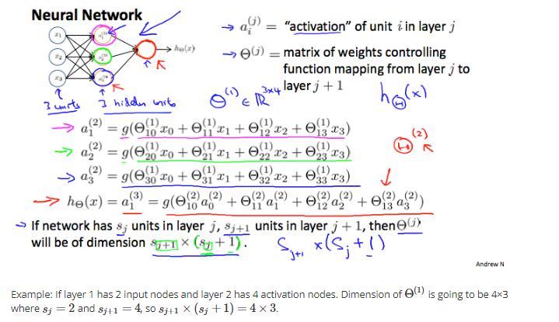

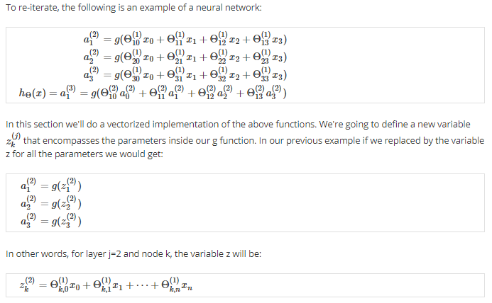

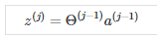

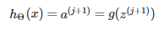

This is how a simplest neural network can be developed forming a functionality of AND gate

Since hypothesis is made up of sigmoid function, it will output binary. Now if we consider that the inputs i.e. x1 and x2 will be binary then this network will act like a gate and specifically a AND gate. Similarly other GATES can be created by changing the weights.

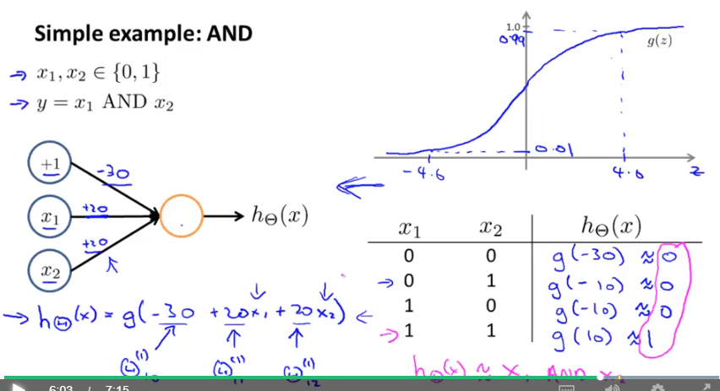

Following network acts like an OR gate. Network is same. Just by changing the weight it startes acting as a different gate.

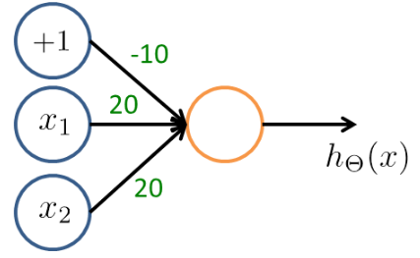

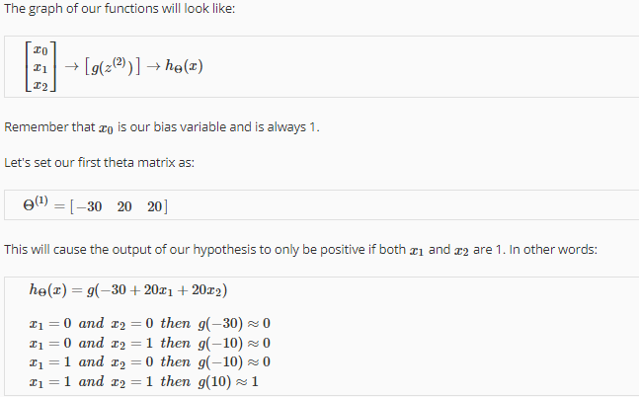

General idea of negating any input is to put a large negative weight for that input.

This is how we can generate a network for XNOR gate. Which is a combination of 3 functions provided by 3 different network. Putting all of them combines can result into XNOR functionality. Here it has hidden layers as well.

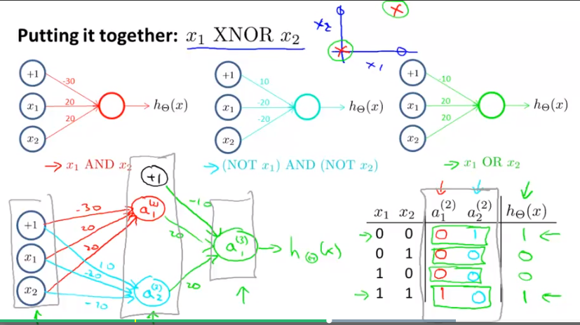

Neural network can be of 2 types. Binary classification and Multi class classification where,

L = Total no. of layers

Sl = no. of layers in layer l

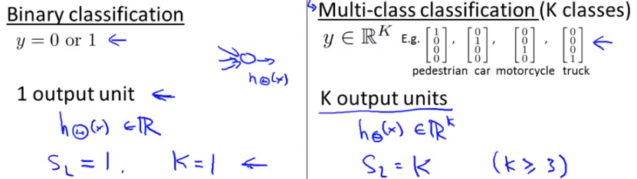

**Cost function of neural network:**

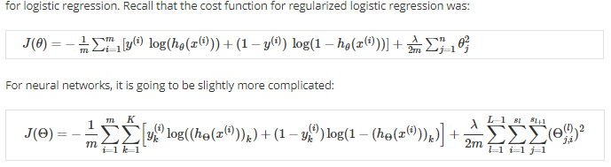

In short the forward propogation of activation values are calculated in following way

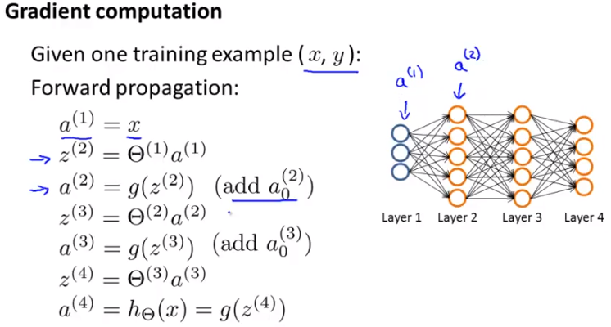

To account for error and self learning, back-propogation method is used. It is nothing but calculation of delta term. It starts from last layer and goes upto 2nd layer in reverse direction

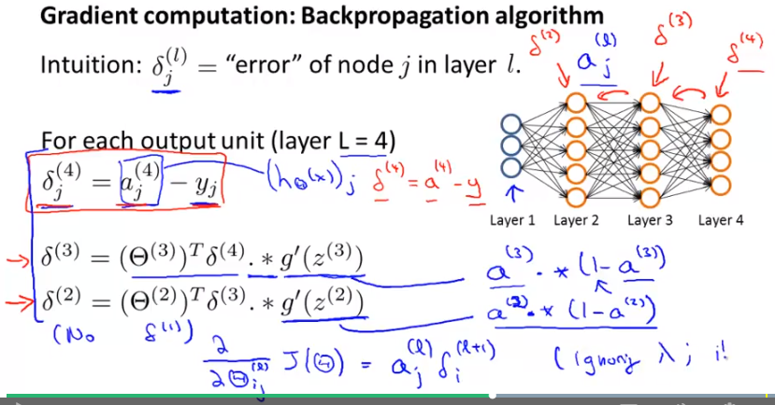

These are the steps for calculating the output using the back propogation method.

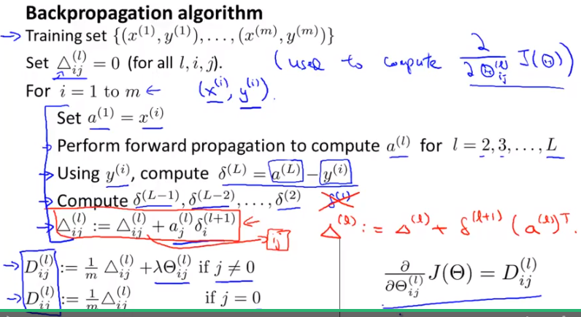

This is how deltas in back propogation can be calculated

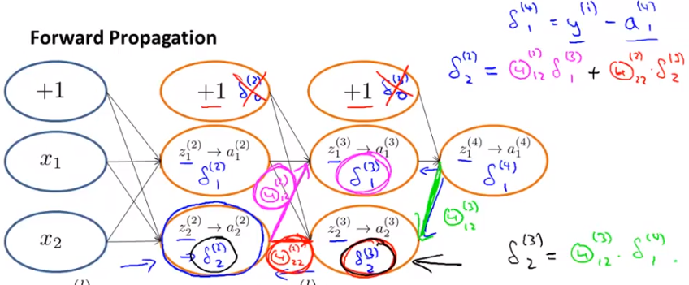

**How to use omptimized functions like fminunc for neural network.**

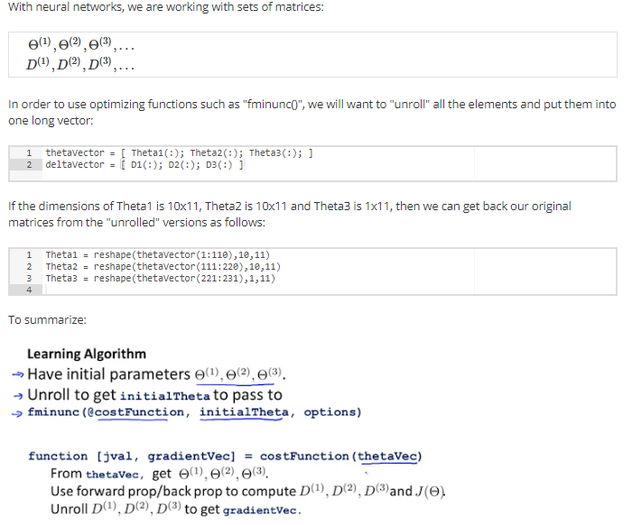

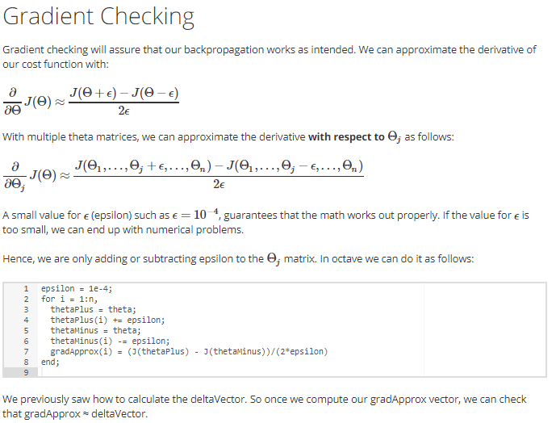

Once you have verified that your backpropagation algorithm is correct, you don't need to compute gradient computation again. The code to compute gradient calculation can be very slow than back propogation method.

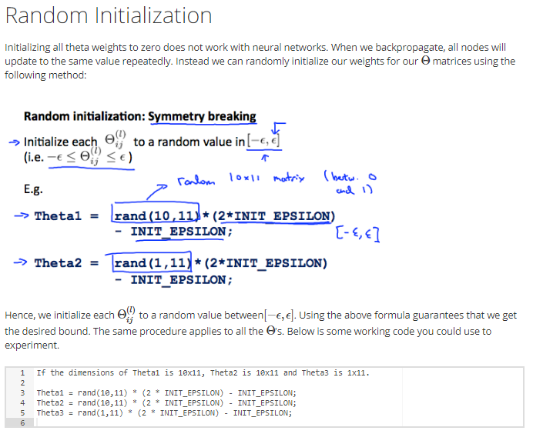

# Putting it Together

**Step-1: Selecting Network Architecture**

First, pick a network architecture; choose the layout of your neural network, including how many hidden units in each layer and how many layers in total you want to have.

* Number of input units = dimension of features *x*(*i*)
* Number of output units = number of classes
* Number of hidden units per layer = usually more the better (must balance with cost of computation as it increases with more hidden units)
* Defaults: 1 hidden layer. If you have more than 1 hidden layer, then it is recommended that you have the same number of units in every hidden layer.

**Step-2: Training a Neural Network**

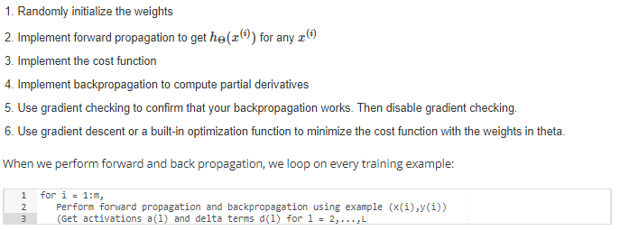

**Neural Network Diagnosis**

If the predictions are quite errornous then user can try out any of following things.

1. Add more training examples
2. Add no. of features
3. Reduce no. of features
4. Increase lambda
5. Decrease lambda
6. Try adding polynomial features

But this may take so long time to implement all of these and there are chances that not all will improve the algorithm. So to find out which technique will work the best, we have to resort to diagnosis which lets easy identification of right technique to improve learning of the algorithm.

First thing is to evaluate our hypothesis. A hypothesis may have a low error for the training examples but still be inaccurate (because of overfitting). Thus, to evaluate a hypothesis, given a dataset of training examples, we can split up the data into two sets: a **training set** and a **test set**. Typically, the training set consists of 70 % of your data and the test set is the remaining 30 %.

The new procedure using these two sets is then:

1. Learn Θ and minimize *Jtrain*(Θ) using the training set
2. Compute the test set error *Jtest*(Θ)

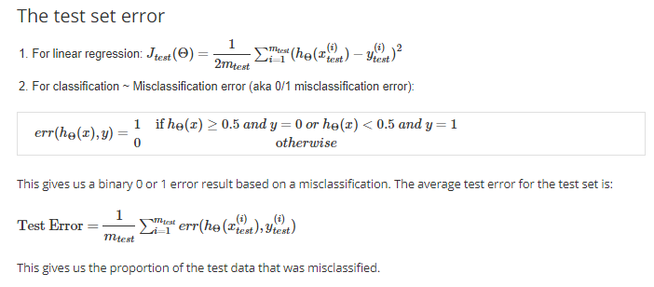

# **Model Selection and Train/Validation/Test Sets**

Just because a learning algorithm fits a training set well, that does not mean it is a good hypothesis. It could over fit and as a result your predictions on the test set would be poor. The error of your hypothesis as measured on the data set with which you trained the parameters will be lower than the error on any other data set.

Given many models with different polynomial degrees, we can use a systematic approach to identify the 'best' function. In order to choose the model of your hypothesis, you can test each degree of polynomial and look at the error result.

One way to break down our dataset into the three sets is:

* Training set: 60%
* Cross validation set: 20%
* Test set: 20%

We can now calculate three separate error values for the three different sets using the following method:

1. Optimize the parameters in Θ using the training set for each polynomial degree.
2. Find the polynomial degree d with the least error using the cross validation set.
3. Estimate the generalization error using the test set with *Jtest*(Θ(*d*)), (d = theta from polynomial with lower error);

This way, the degree of the polynomial d has not been trained using the test set.

**Whenever a model is not working, it can be because of underfitting or overfitting problems.**

# Diagnosing Bias vs. Variance

In this section we examine the relationship between the degree of the polynomial d and the underfitting or overfitting of our hypothesis.

* We need to distinguish whether bias or variance is the problem contributing to bad predictions.
* High bias is underfitting and high variance is overfitting. Ideally, we need to find a golden mean between these two.

The training error will tend to decrease as we increase the degree d of the polynomial. At the same time, the cross validation error will tend to decrease as we increase d up to a point, and then it will increase as d is increased, forming a convex curve.

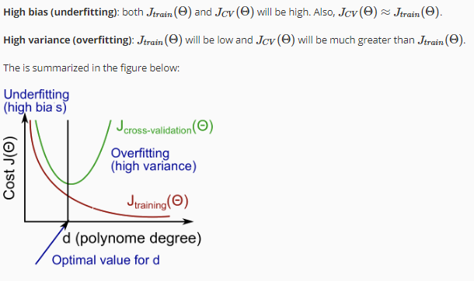

# Regularization and Bias/Variance

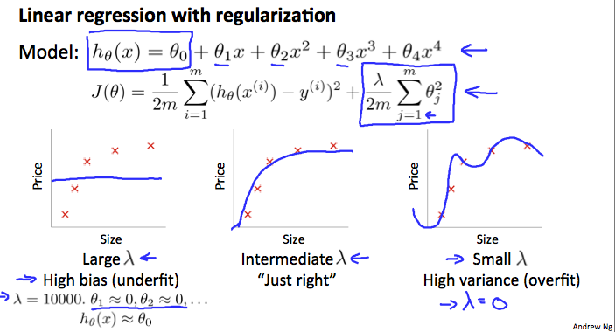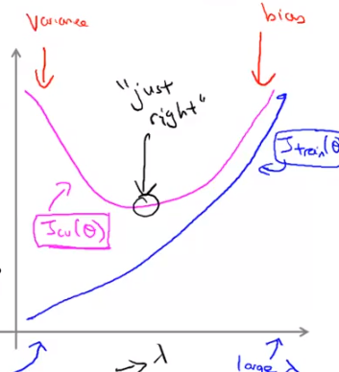

In the figure above, we see that as *λ* increases, our fit becomes more rigid. On the other hand, as *λ* approaches 0, we tend to over overfit the data. So how do we choose our parameter *λ* to get it 'just right' ? In order to choose the model and the regularization term λ, we need to:

1. Create a list of lambdas (i.e. λ∈{0,0.01,0.02,0.04,0.08,0.16,0.32,0.64,1.28,2.56,5.12,10.24});
2. Create a set of models with different degrees or any other variants.
3. Iterate through the *λ*s and for each *λ* go through all the models to learn some Θ.
4. Compute the cross validation error using the learned Θ (computed with λ) on the *JCV*(Θ) without regularization or λ = 0.
5. Select the best combo that produces the lowest error on the cross validation set.
6. Using the best combo Θ and λ, apply it on *Jtest*(Θ) to see if it has a good generalization of the problem.

# Learning Curves

Training an algorithm on a very few number of data points (such as 1, 2 or 3) will easily have 0 errors because we can always find a quadratic curve that touches exactly those number of points. Hence:

* As the training set gets larger, the error for a quadratic function increases.
* The error value will plateau out after a certain m, or training set size.

**Experiencing high bias:**

Low training set size: causes *Jtrain*(Θ) to be low and *JCV*(Θ) to be high.

Large training set size: causes both *Jtrain*(Θ) and *JCV*(Θ) to be high with *Jtrain*(Θ)≈*JCV*(Θ).

**If a learning algorithm is suffering from high bias, getting more training data will not (by itself) help much.**

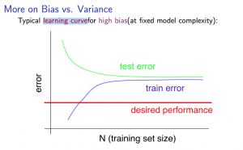

**Experiencing high variance:**

Low training set size: *Jtrain*(Θ) will be low and *JCV*(Θ) will be high.

Large training set size: *Jtrain*(Θ) increases with training set size and *JCV*(Θ) continues to decrease without leveling off. Also, *Jtrain*(Θ) < *JCV*(Θ) but the difference between them remains significant.

**If a learning algorithm is suffering from high variance, getting more training data is likely to help.**

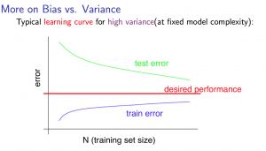

**Decision process for resolving errors**

* Getting more training examples: Fixes high variance
* Trying smaller sets of features: Fixes high variance
* Adding features: Fixes high bias
* Adding polynomial features: Fixes high bias
* Decreasing λ: Fixes high bias
* Increasing λ: Fixes high variance.

### **Diagnosing Neural Networks**

* A neural network with fewer parameters is prone to underfitting. It is also computationally cheaper.
* A large neural network with more parameters is prone to overfitting. It is also computationally expensive. In this case you can use regularization (increase λ) to address the overfitting.

Using a single hidden layer is a good starting default. You can train your neural network on a number of hidden layers using your cross validation set. You can then select the one that performs best.

**Model Complexity Effects:**

* Lower-order polynomials (low model complexity) have high bias and low variance. In this case, the model fits poorly consistently.
* Higher-order polynomials (high model complexity) fit the training data extremely well and the test data extremely poorly. These have low bias on the training data, but very high variance.
* In reality, we would want to choose a model somewhere in between, that can generalize well but also fits the data reasonably well.

**Spam Classifier:**

Given a data set of emails, we could construct a vector for each email. Each entry in this vector represents a word. The vector normally contains 10,000 to 50,000 entries gathered by finding the most frequently used words in our data set. If a word is to be found in the email, we would assign its respective entry a 1, else if it is not found, that entry would be a 0. Once we have all our x vectors ready, we train our algorithm and finally, we could use it to classify if an email is a spam or not.

So how could you spend your time to improve the accuracy of this classifier?

* Collect lots of data (for example "honeypot" project but doesn't always work)
* Develop sophisticated features (for example: using email header data in spam emails)
* Develop algorithms to process your input in different ways (recognizing misspellings in spam).

It is difficult to tell which of the options will be most helpful.

# **Error Analysis**

The recommended approach to solving machine learning problems is to:

* Start with a simple algorithm, implement it quickly, and test it early on your cross validation data.
* Plot learning curves to decide if more data, more features, etc. are likely to help.
* Manually examine the errors on examples in the cross validation set and try to spot a trend where most of the errors were made

For example, assume that we have 500 emails and our algorithm misclassifies a 100 of them. We could manually analyze the 100 emails and categorize them based on what type of emails they are. We could then try to come up with new cues and features that would help us classify these 100 emails correctly. Hence, if most of our misclassified emails are those which try to steal passwords, then we could find some features that are particular to those emails and add them to our model. We could also see how classifying each word according to its root changes our error rate:

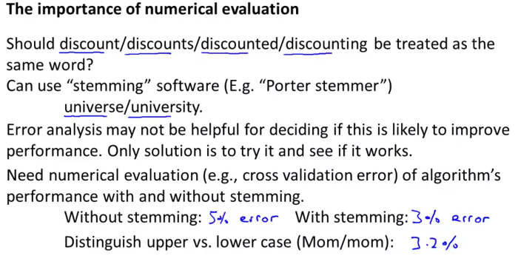.

It is very important to get error results as a single, numerical value. Otherwise it is difficult to assess your algorithm's performance. For example if we use stemming, which is the process of treating the same word with different forms (fail/failing/failed) as one word (fail), and get a 3% error rate instead of 5%, then we should definitely add it to our model. However, if we try to distinguish between upper case and lower case letters and end up getting a 3.2% error rate instead of 3%, then we should avoid using this new feature. Hence, we should try new things, get a numerical value for our error rate, and based on our result decide whether we want to keep the new feature or not.

**Skewed Class**

If the number of positive samples for a class is very less say 0.5% or so then that is called skewed classes.

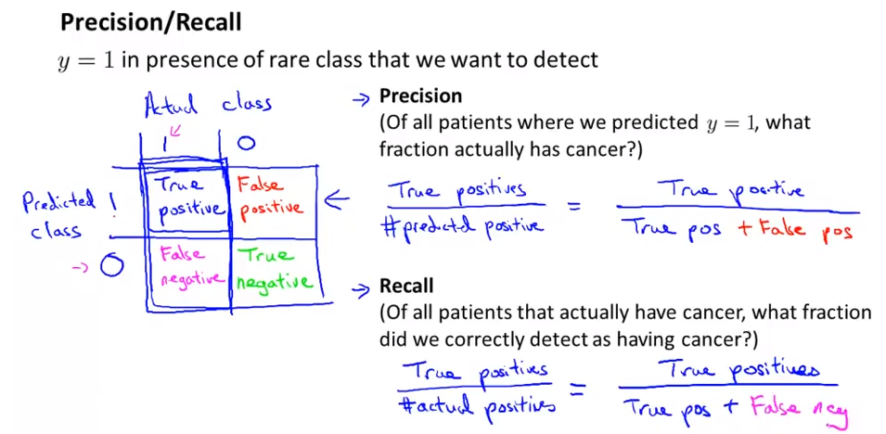

Precision and Recall are the very important evaluation parameters for finding how algorithm behaves. If the Precision and Recall are then it gives us a good confidence that algorithm is working fine even if there are skewed classes.

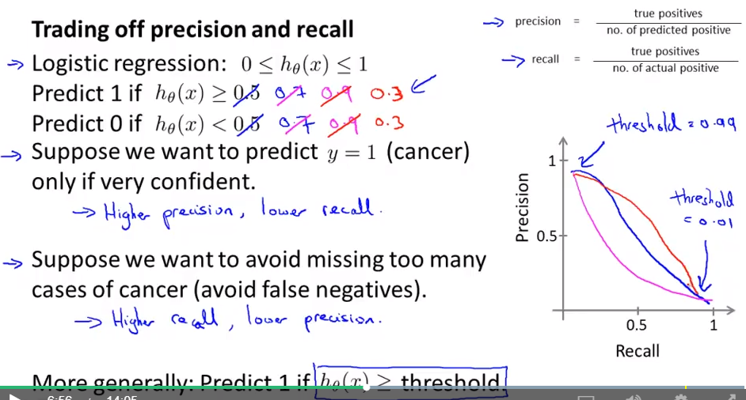

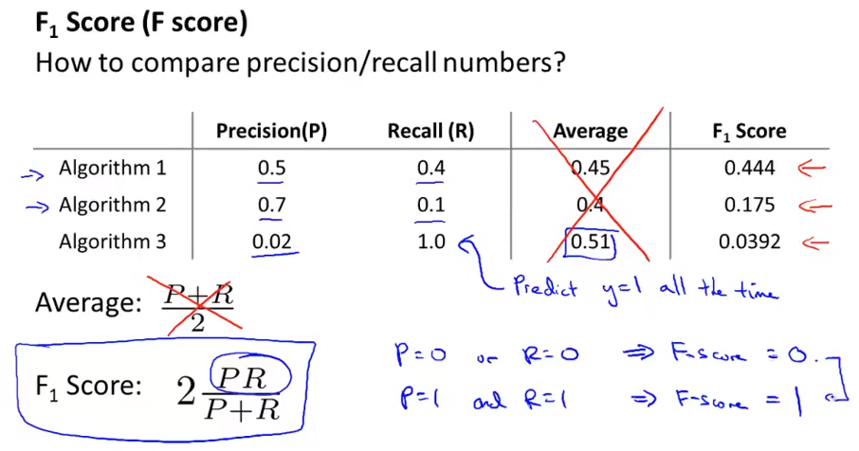

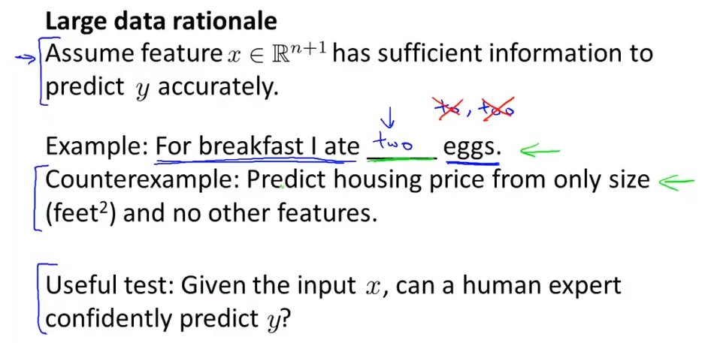

Provide sufficient features to avoid high bias or underfit.

Provide sufficient training set to avoid overfit

**Support Vector MAchine**

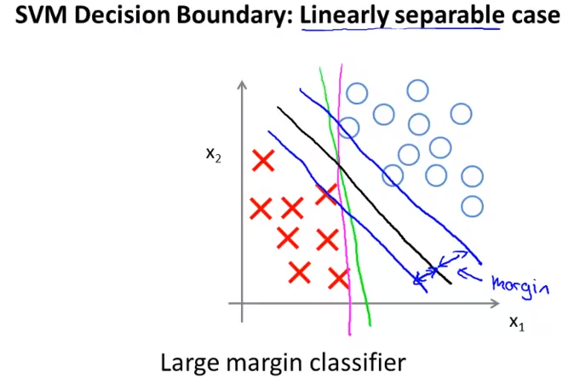

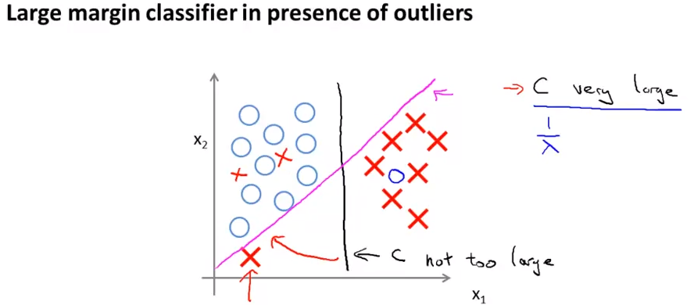

C = 1/Lambda

If lambda is very small then C will be large and can result in decision boudary as magenta colour line because of the outlier present at the bottom left corner. This is a case of high variance. But if C is not too large then a decision boundary with black can be achieved with eliminating effect of outliers. This is the case of higher bias compared to previous case.

SVM has a feature to ignore outliers and find the decision boundary that has maximum margin. Hence, we can say, SVM is robust to outliers.

SVM also supports non linear decision boundary.To support that, we change the hypothesis to  Here f1, f2, f3 are the combination of input parameters and they are called as similarity functions. There are various similarity functions out of which following is the gaussian similarity function. These functions are called **kernel**

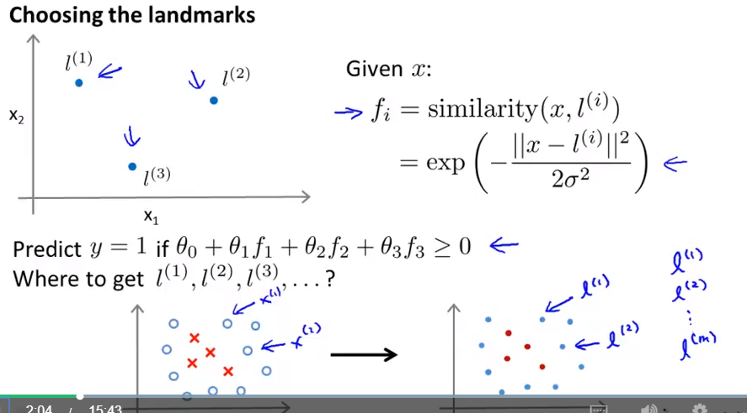

Steps in SVM:

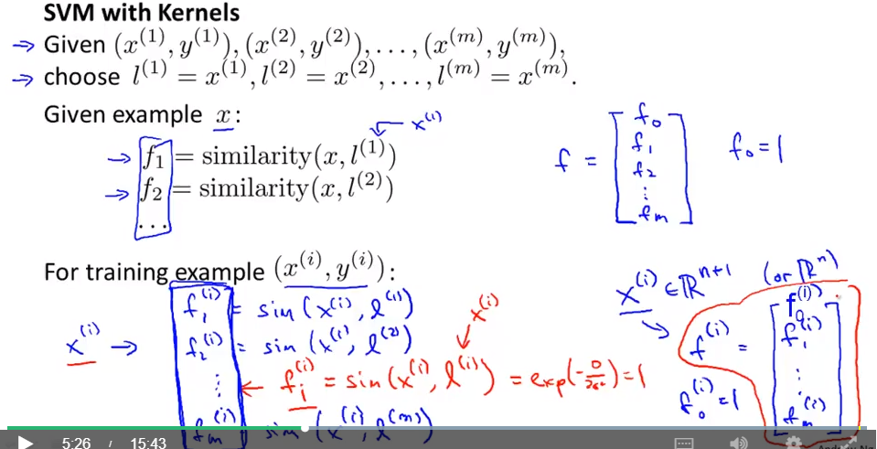

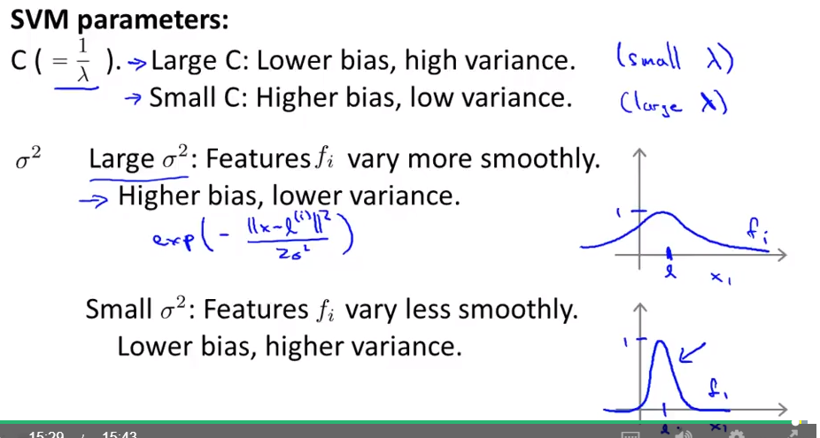

Do not try to create softwares for SVM. There are already a bunch libraries available to calculate SVM. Use that. We just have to specify parameter C and choice of Kernel. No kernel is also called as linear kernel. I.e. 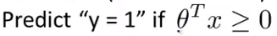

Feature scaling is important before using gaussian kernel.

**When to use what?**

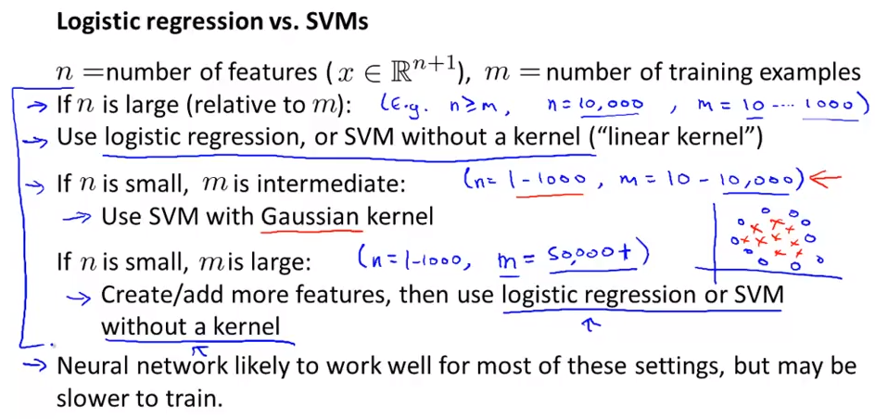

**Unsupervised Learning**

Examples:

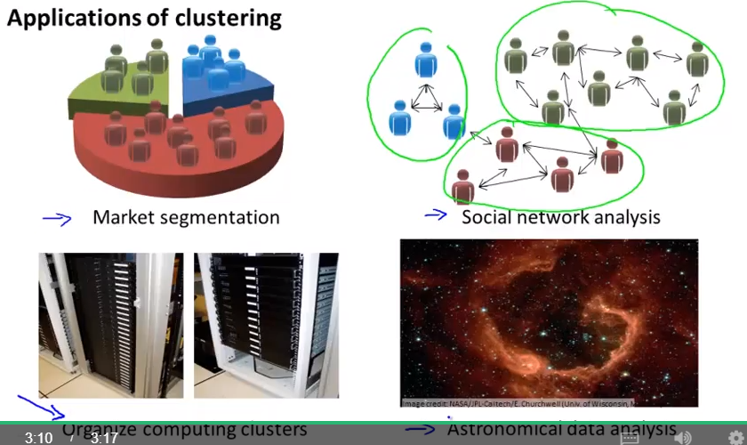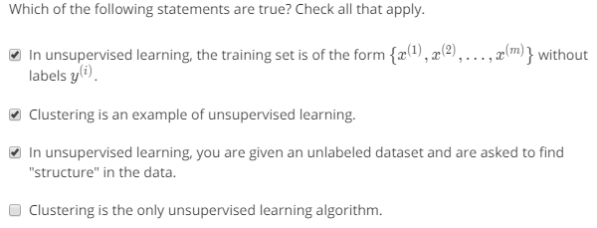

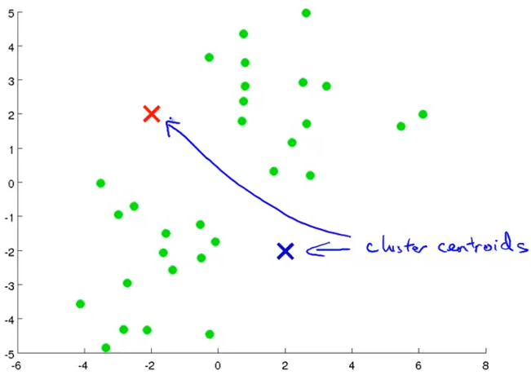<- Initial data. See how it evolves to create cluster step by step

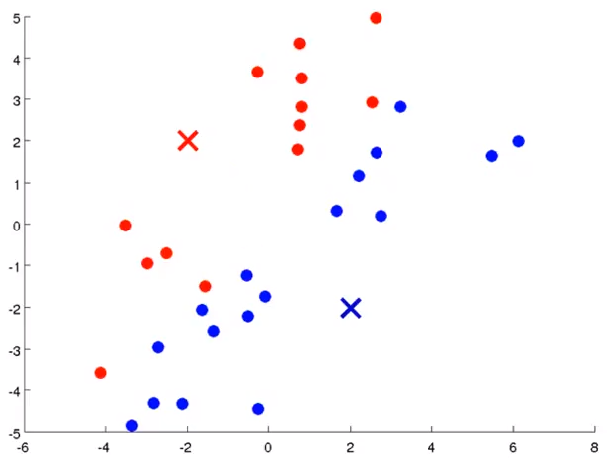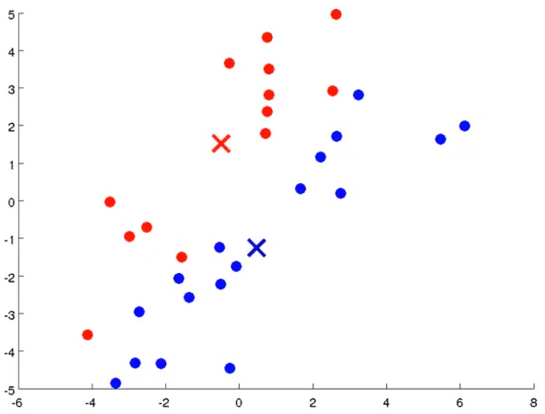

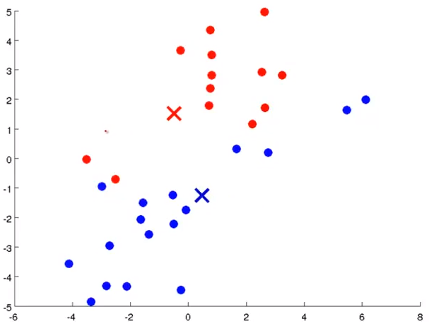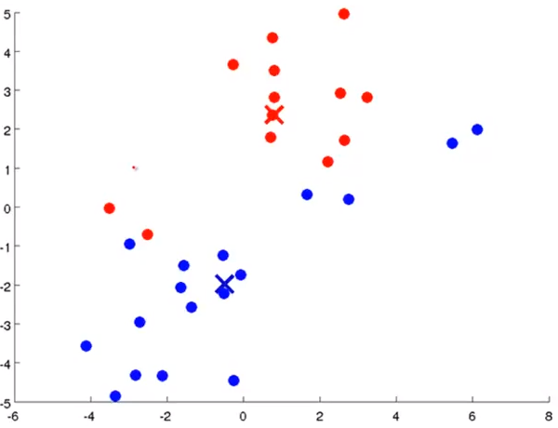

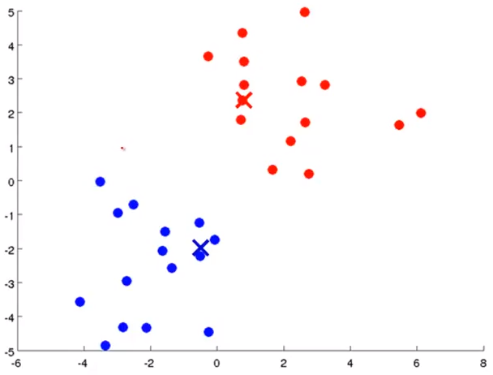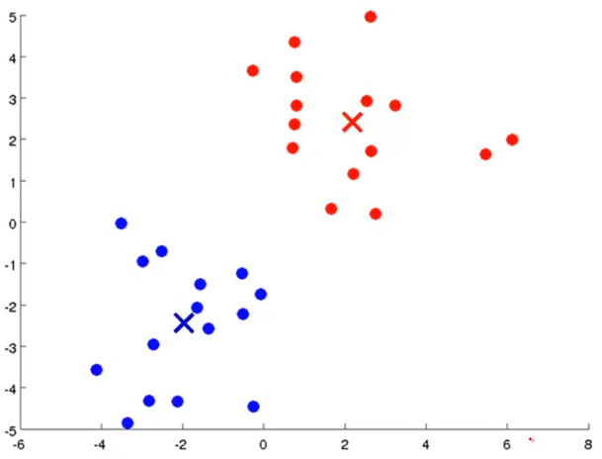

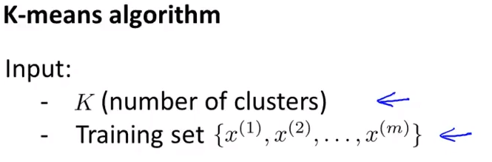

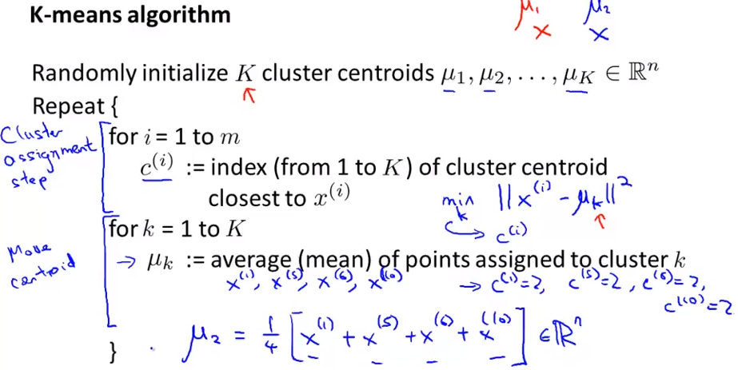

Mu is the centroid positions.

K is the number of clusters

k is the index to centroids/clusters

c is the index of cluster (temporary variable)

X is the data points

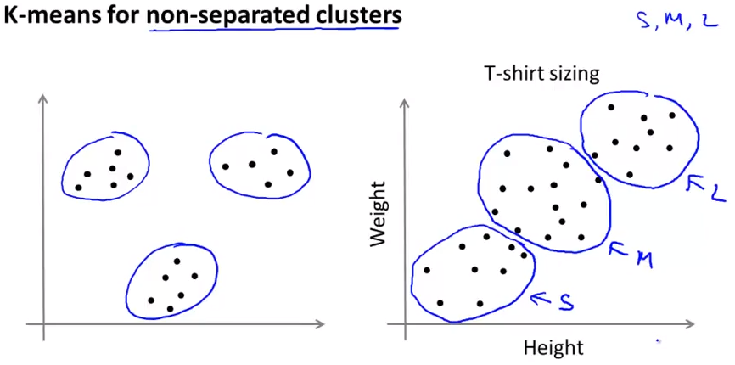

If the data set is non seperable, K-Means will help in market segmentation

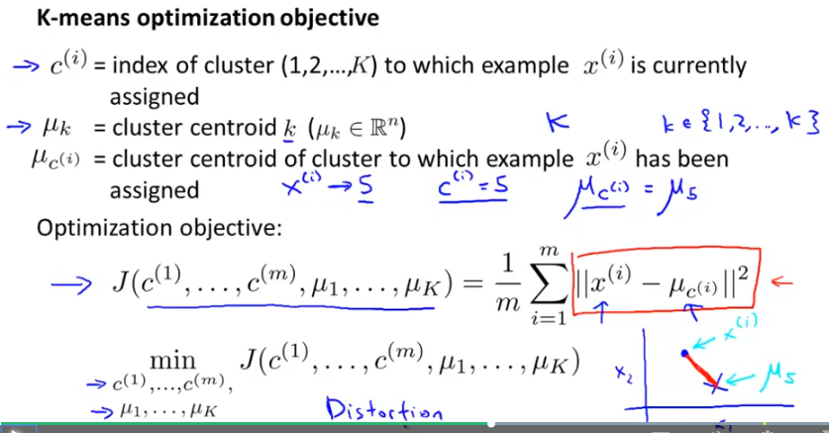

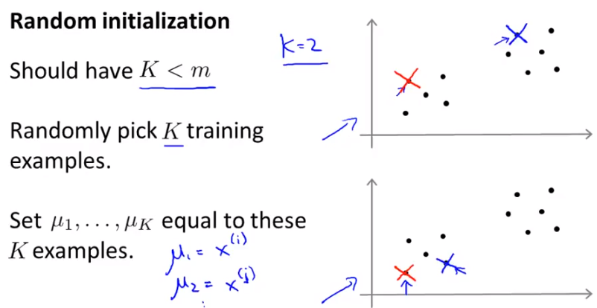

After random initialization, and after number of iterations, it will find the right centroids. But many times it does not find right centroids due to local optima as shown below.

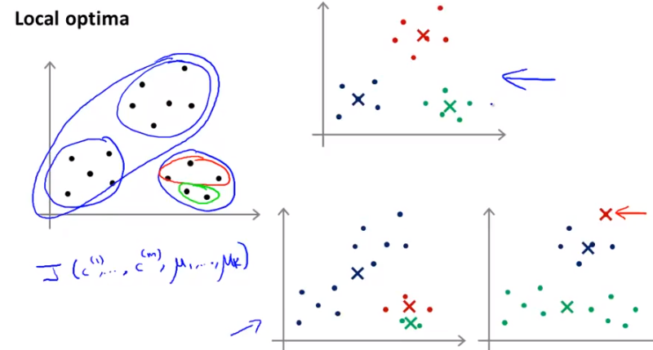

The top graph shows expected clustering but sometimes wrong clustering may occur as shown in lower 2 graphs. This local optima can happen because of the incorrect initialization. To solve this we can run clustering algorithm for number of times with different initialization everytime.

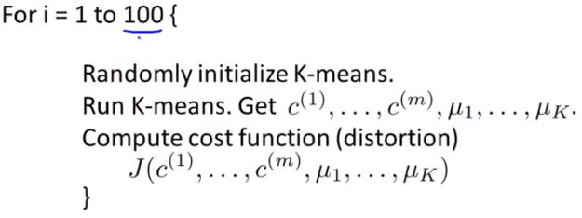



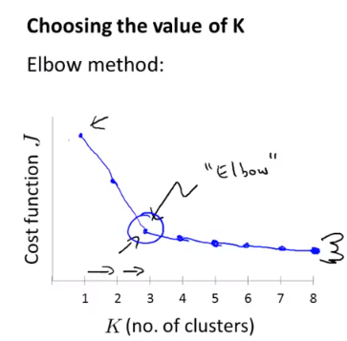Highest angle change can guide how many number of clusters should be there

**Dimension reduction / Data compression:**

This is another technique that will help in machine learning. Say if there are engineering team1 who found 100 features, another engineering team found another 300 feature, then it is worth to look at if there are any feature which you can reduce.

In following example, it looks like same feature measured in different units and because of round off errors, the points are not falling exactly on the line. So in this scenario, if we try to apply dimensional reduction technique then each data point on the XY plane (feature1 to feature 2 plane) can be projected to a single line (forming the 3rd feature) and then we can neglect the first 2 features.

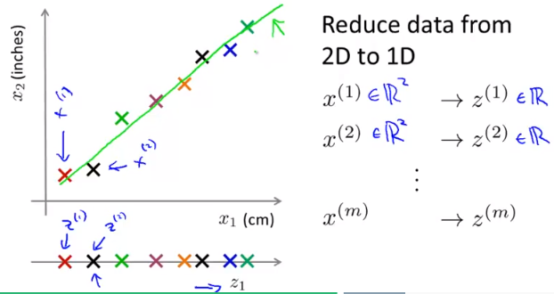

**Reduce 3D data into 2D**

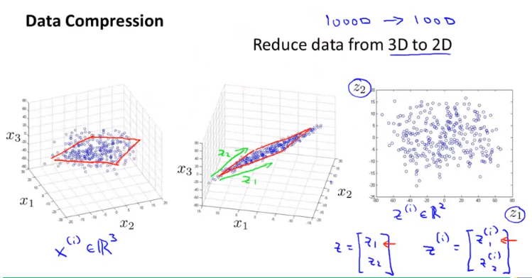

This is an example of reducing 3D data into 2D. This should be done only after verifying whether the data points in 3D plot almost look like to be on a plane or not. If so, we can apply dimension reduction technique. In reality we would use reduction from 1000D to around 100D.

Let us see one more example -

Say the dat is like this, having multiple features.

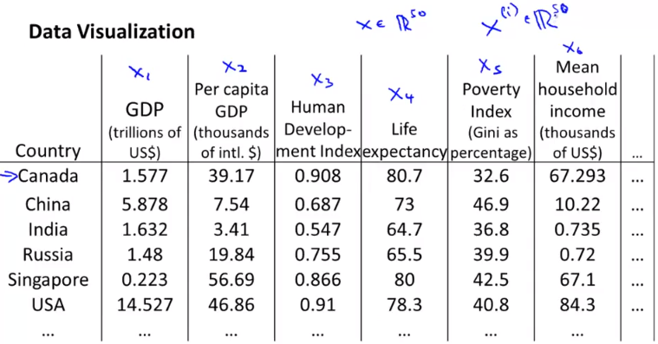

Now these data can be projected to a 2 new features.

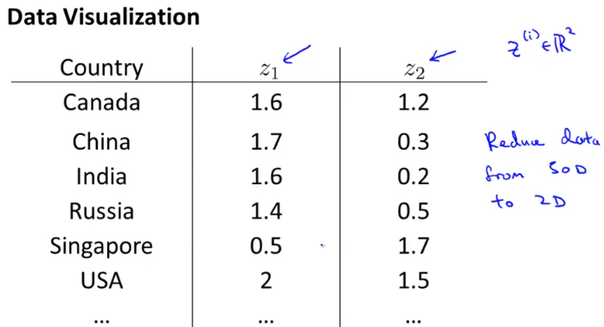

Since now the data is in 2D, we can visualize it where both new features (z1 and z2) are axes and we are platting each country name as a data point.

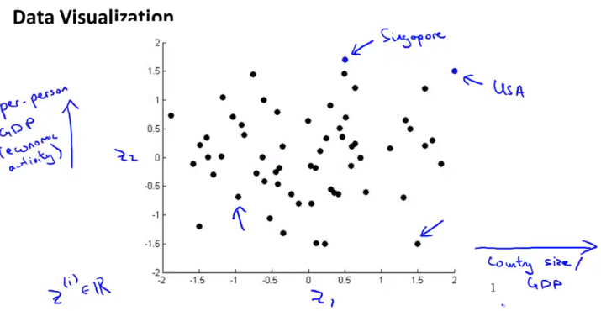

**Principal Component Analysis**

One of the most common method of dimension reduction method is PCA.

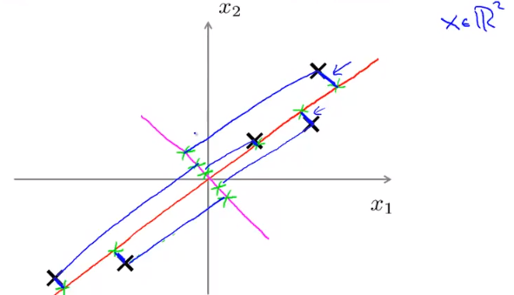

In PCA, each of the data point is projected onto a line which reduces the squared distance of each point from the line. Here we have shown 2 examples (red line and magenta line) along with the projection of data points on those lines. Naturally the red line wins the race as the distance of those points are lesser than others. So the red line vector is the Principal component. The distances are also called as projection error.

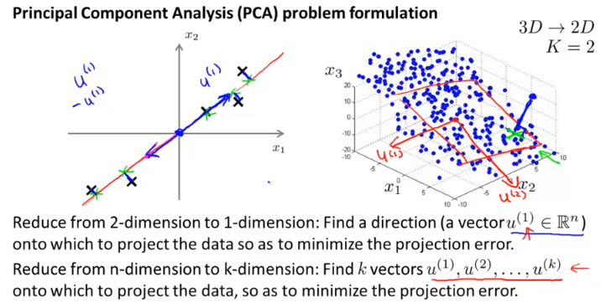

This example shows how 3D data is also projected on 2D plane. Note a sample projection marked in green.

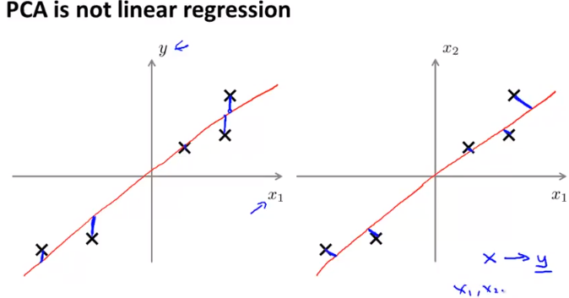

PCA is not linear regression. In linear regression, we find vertical distance of data points to the hypothesis whereas in PCA we find the normal distance. Also in linear regression the plot is between x and y, and y is a special dimension which we are trying to predict where as in PCA the plot is between different different features and each feature has equal importance.

**Procedure to Calculate PCA**

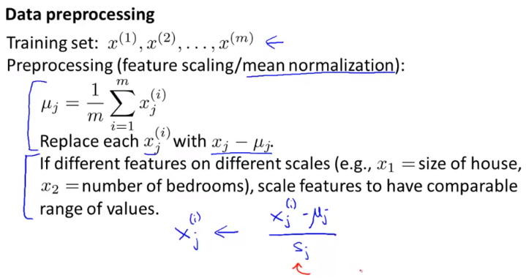

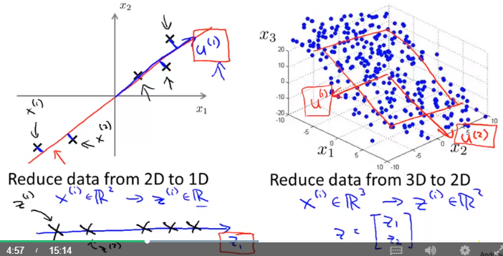

There 2 basic steps

1. Calculate vector u(1) and u(2)
2. Find points z1, z2, z3 etc

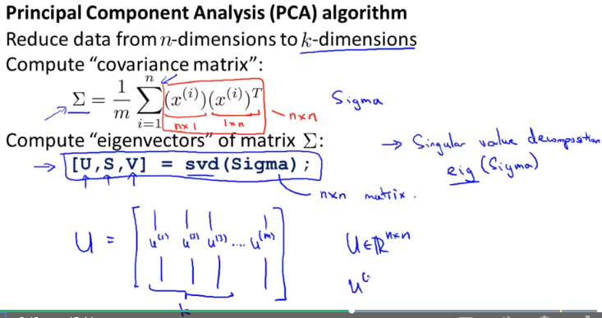

In a nutshell -

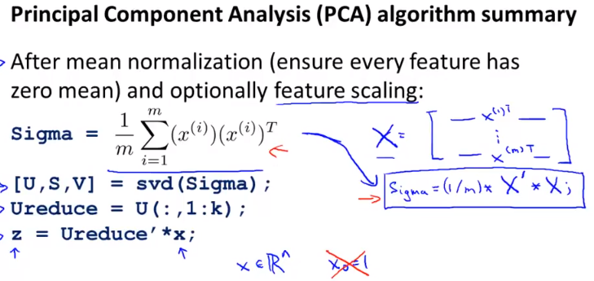

**Reconstruction from compressed representation**

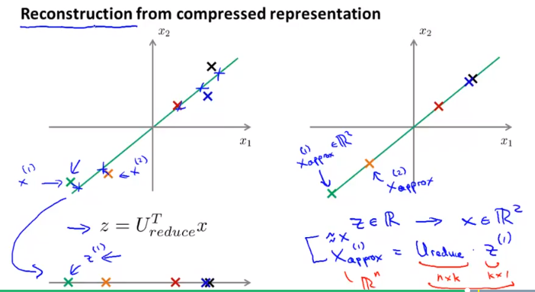

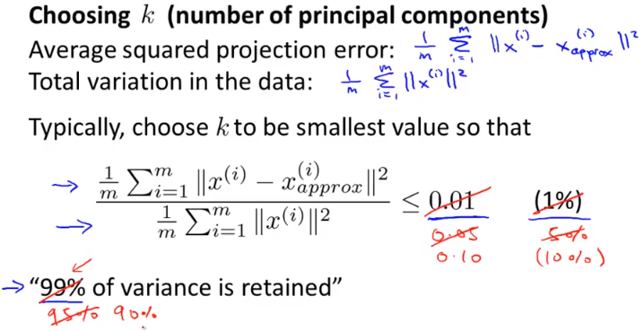

One of the important quality measure of the PCA is % variance retained even after reducing the dimensions.

**Two ways to find optimum value of k**

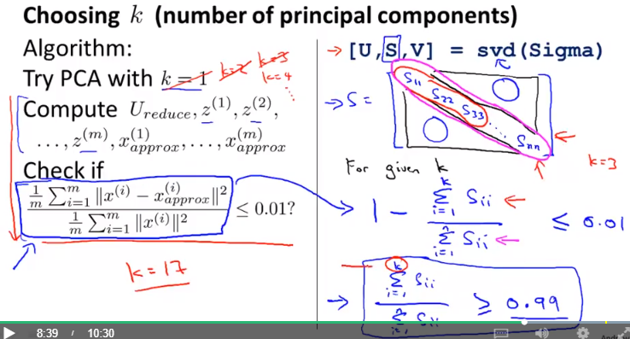

The first method involves lot of iterative calculations. So the 2nd approach is much efficient. We anyways call svd() to calculate feature vectors U. Calculations on S matrix is much faster than 1st approach.

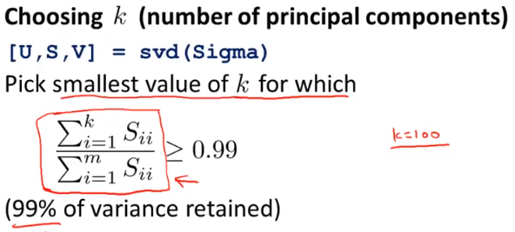

**Supervised Learning Speedup**

PCA can be used to improve supervised learning as well to speedup by reducing number of features

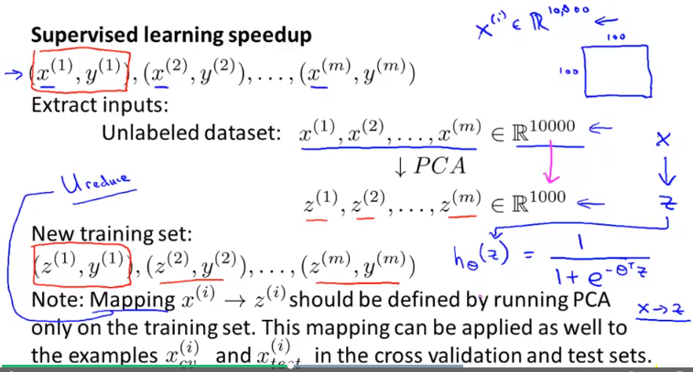

**Some people use PCA to resolve overfitting problems. This might work but that is not the right approach of addressing overfitting, instead we should use regularization.**

**Another advise is do not plan for PCA in any machine learning algorithm. But instead run the algorithm with original data first and if you find the processing takes too much of time only then apply PCA.**

**Anomaly detection**

Anomaly is nothing but an unusual behaviour. Unusual is nothing but very low probable scenario. So by looking at the probability of existing data set and checking the probability test data, can tell you whether the data is anomalous or not.

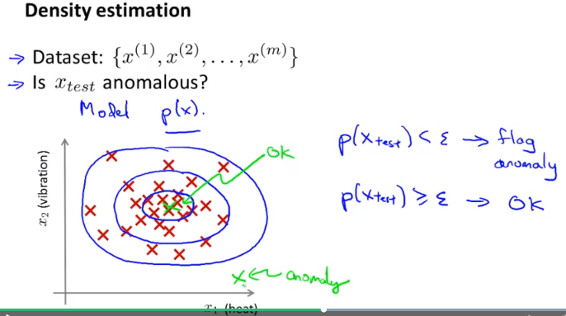

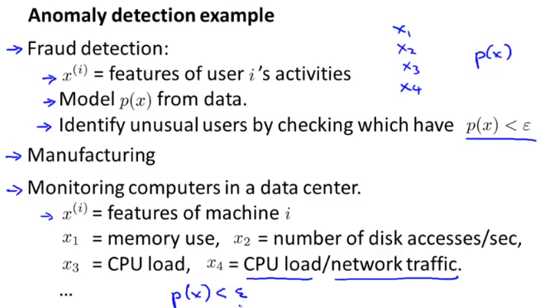

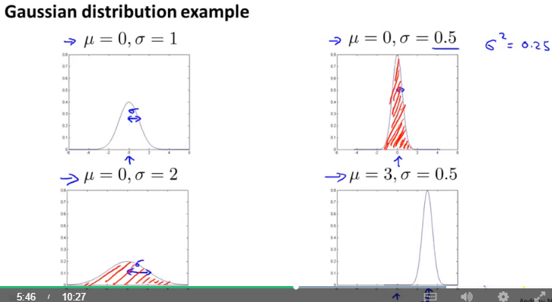

Mu is the mean and maximum of the samples of x will be around mean. Number of samples varying from mean to acceptable limit is standard deviation (denoted by sigma). Variance is nothing but the square of sigma. The area under the bell shape will always be 1. So it standard deviation is less, the height of the curve will increase.

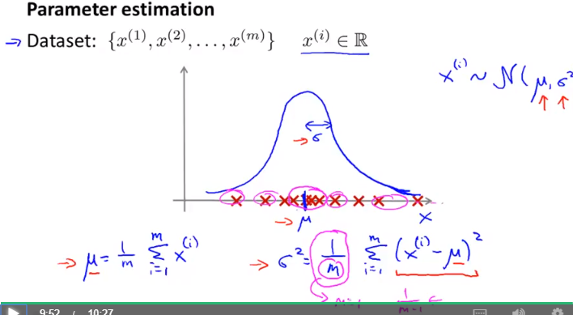

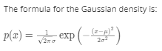

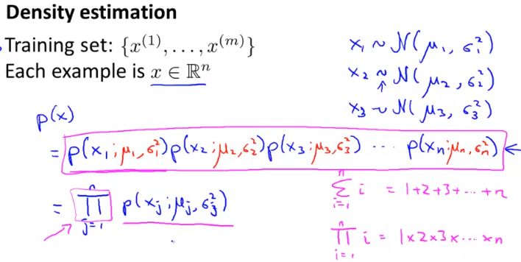

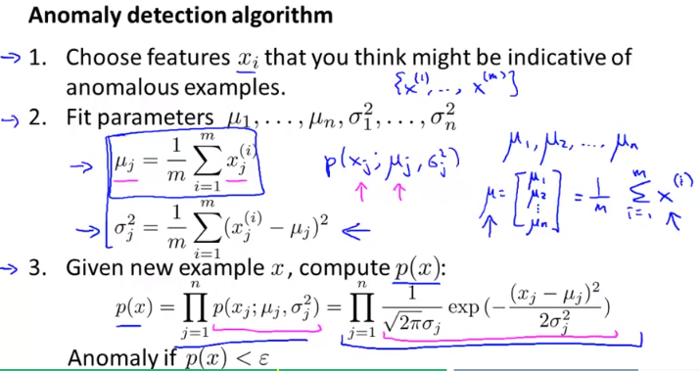

Anomaly detection algorithm Graphically

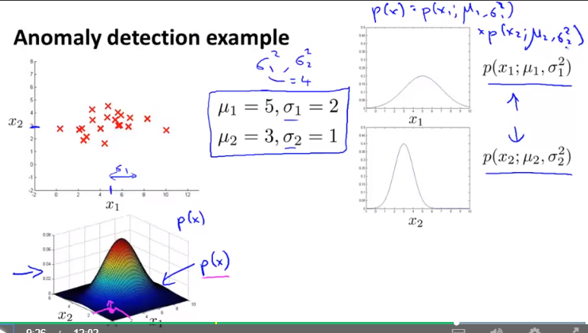

Say you have a data set of 10000 labelled samples out of which 20 samples are anomalous then this how you can split them into various data sets. 2nd approach is not recommended. 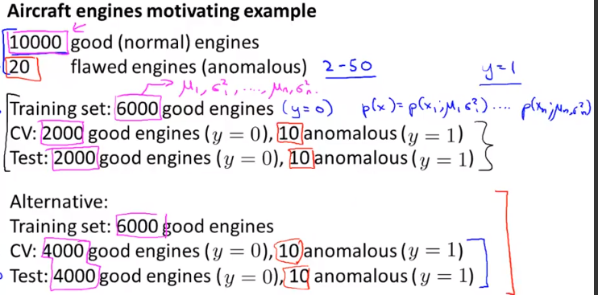

Training set should contain only good examples (non anomalous i.e. y = 0)

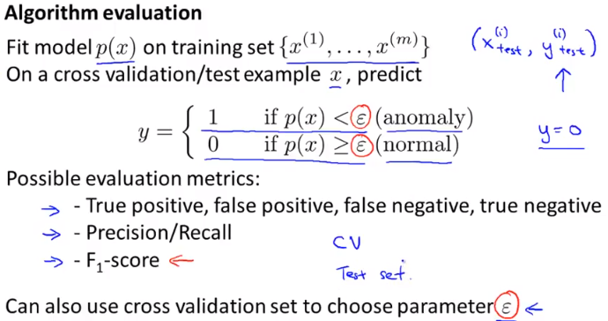

Classification error is not the right measure due to skewed class (chances of y=1 >> y=0)

So we need to use F1 score kind of quality measuring parameter.

When to use Anomaly detection and when to use Logistic regression (supervised learning)

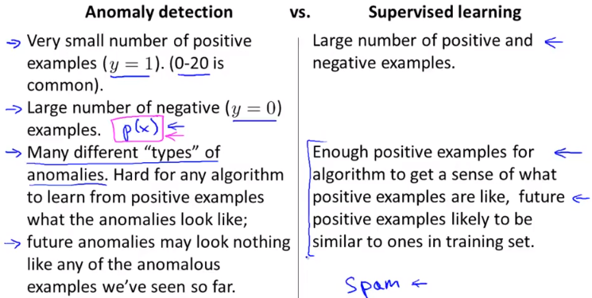

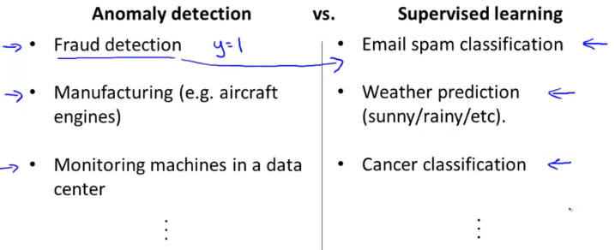

If the number of positive cases for anomaly are too less compared to type of anomaly can occur then we should use anomaly detection. But if we have data showing lot of positive samples, then we can move to supervised learning.

**Selecting the right features**

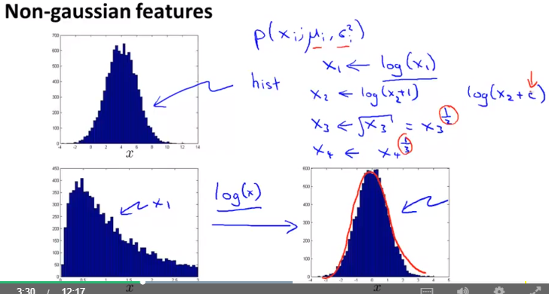

It is advisable to use gaussian distributed features to make it work confidently. In case if the feature is other than gaussian as shown in lower figure, then we can apply some transformation on it to make it look like gaussian distributed. We can apply log, square root, cube root or addition by constant. We can play with these to make it to gaussian.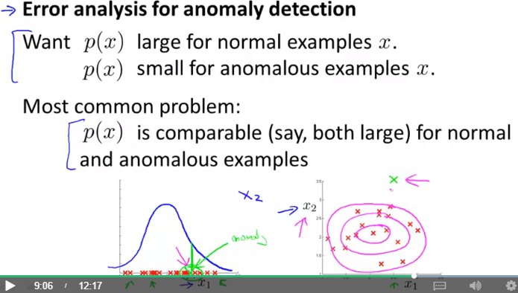

If for any anomalous data, if the feature input is quite possibly occur (pretty high on the bell curve; marked as green), then that’s an indication that we need to consider some other feature as well like x2 and in combination of these 2 values, the anomaly occurs. As shown in 2nd fig., not all samples at particular value of x1 creates anomaly but it occurs for a particular combination. This method of error analysis helps in identifying new features.

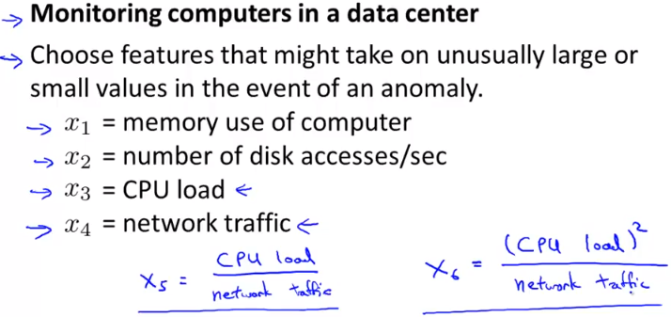

Another example of anomaly detection.

**MultiVariate Gaussian Distribution**

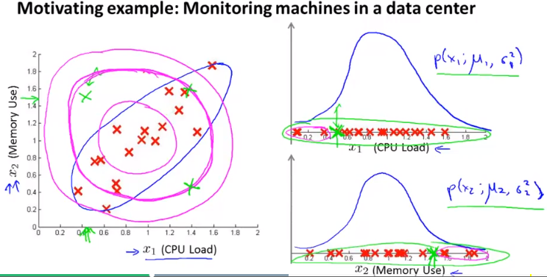

Consider the case of 2 features like CPU load and memory. Look at all the data samples. We expect all the red marks to be non-anomalous and green ones to be anomalous. But since simple Gaussian will consider all the probability circles in circles and since the green one fits under it and it will not be reported as the anomalous. This can also be proved by looking at plotting the x1,x2 values in gaussian curves. To make the probability contours elliptical as shown in blue color, we need to use multivariate gaussian distribution.

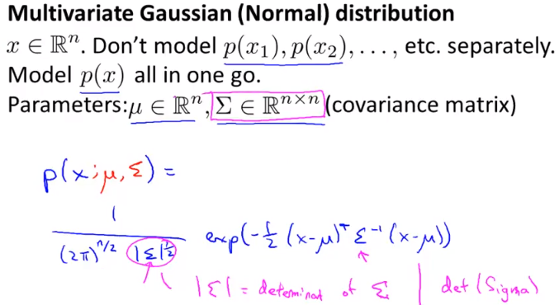

Here in this formula, by changing the value of ‘Mu’ we can shift the centre of the contours across XY plane.By changing the Sigma, we can make the contour elliptical and also rotate to look like diagonal.

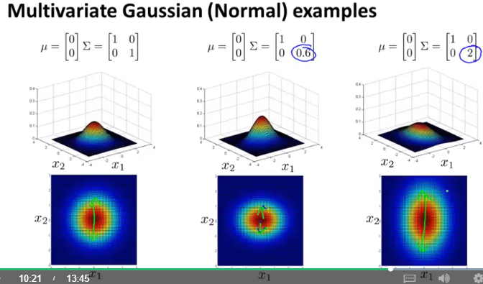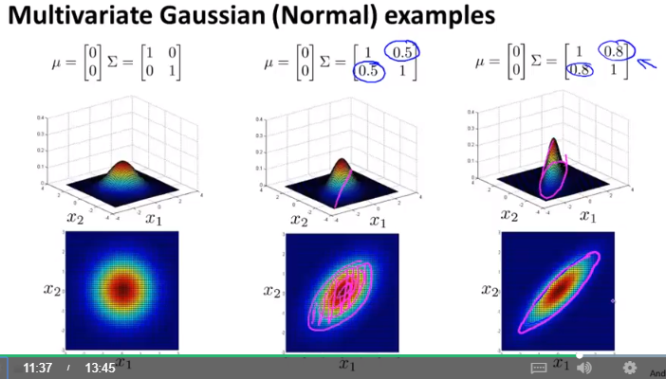

In the original model, if we modify standard deviation, we can achieve contours like 2nd and 3rd. The difference between 2nd and 3rd fig as compared to 6th is off-diagonal elements in Sigma. And so we can say that with multivariate gaussian model we can achieve larger capabilities. Also we can say that original model is a special case of multivariate model.

**Algorithm to calculate multivariate gaussian**

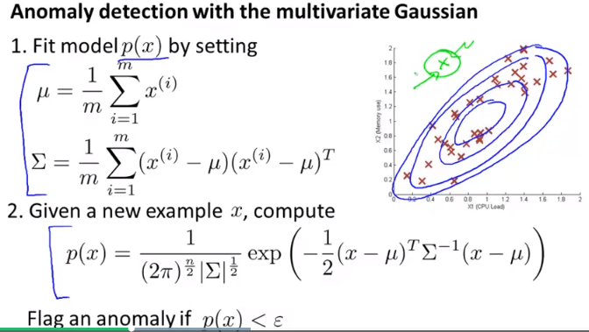

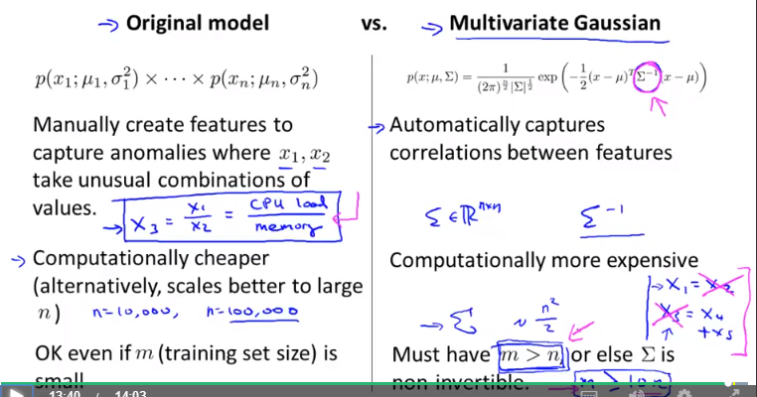

In original model, if green node which was not being identified in earlier examples, then we need to manually identify the new features to take care of it. Whereas multivariate automatically captures it.

**Content based Movie Recommender system**

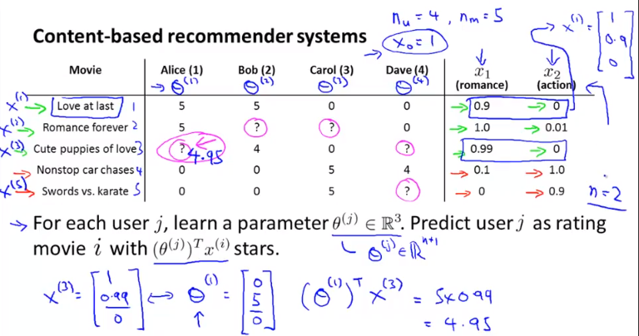

Let's assume we are creating a movie recommender system and say we have the data which specifies the type of movie (represented as x1, x2). And also let's assume we have Theta vector which specifies individual user’s preference for the type of movie then the probability of any user liking a particular movie can be calculated by multiplying Theta and X as shown above. Now the question is how do we calculate the Theta which is the user’s parameters (user’s rating towards type of movie).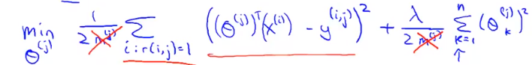

This problem can be simply solved by having a linear regression model for each user to calculate his choice towards type of movies.And this should be done for all the users using this formula. We can apply gradient descent for this. 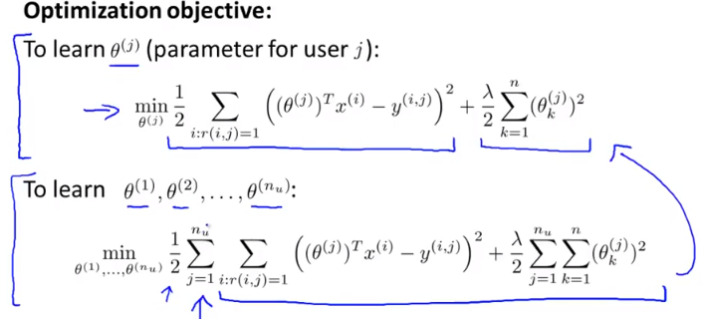

This approach is called content based approach because based on the content of the movie, the features of movie was already given to us i.e. X vector. But for many instances we do not have that features, then in that case we should use collaborative filtering approach.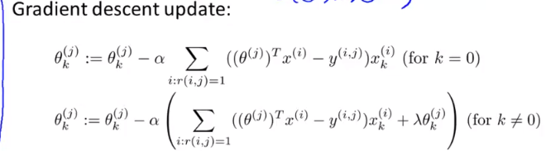

**Collaborative filtering:**

In the previous case we had feature vector(X) and we calculated user vector(Theta). But in case if have Theta and want to calculate X, then we can use following formula.

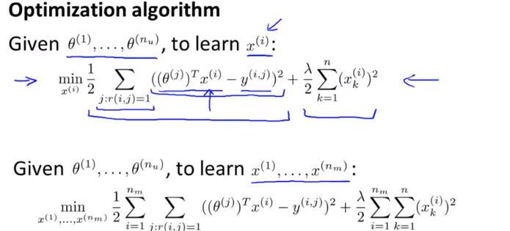

**This means**

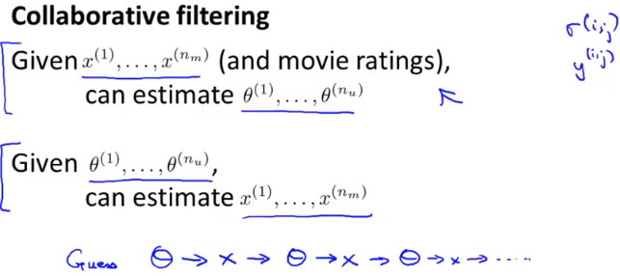

Sometimes there are chances that we do not have X as well as Theta.Then we can assume a sample Theta and based on that we can calculate X. Based on this new X, again we can calculate Theta and this can repeat till we get satisfactory results.

This is possible for recommender system because each user rates multiple movies and each movie is rated by multiple users.

To avoid the iterative process, both the above components can be combined in single formula as below.

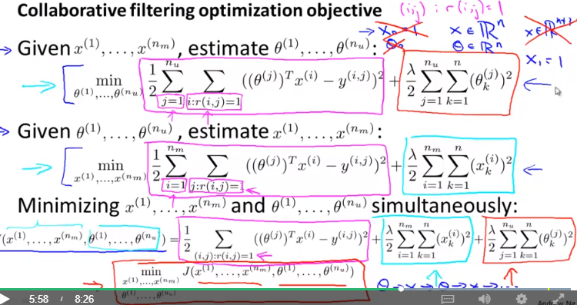

**Low Rank Matrix Factorization**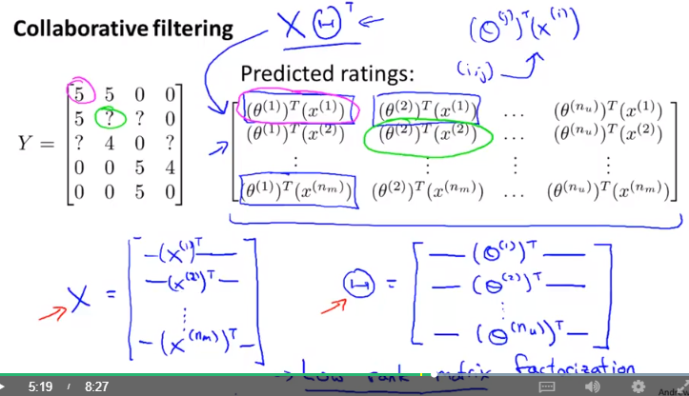

: Can be represented this way.

**How to find the related movies / products?**

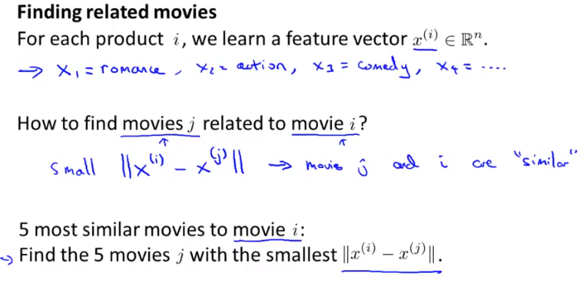

When we calculate the feature vector we do not what do the features X1, X2 etc mean but they effectively mean some angle of the type of movie. To find out which movie/product is related to other we can simply calculate the distance between values of X.

**What is a new user joins?**

What rating should we consider for the new user? It will result into a Theta vector with all 0 elements. And hence the predicted values also become 0. This means the distance to all the movies element will be too large and we will not be able to suggest them anything. Thats because product of Theta and X is 0.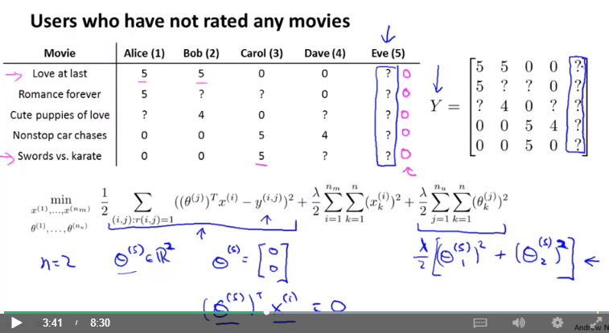

To solve above mentioned problem we can apply mean normalization so that if the product is 0, mean value of rating comes into play.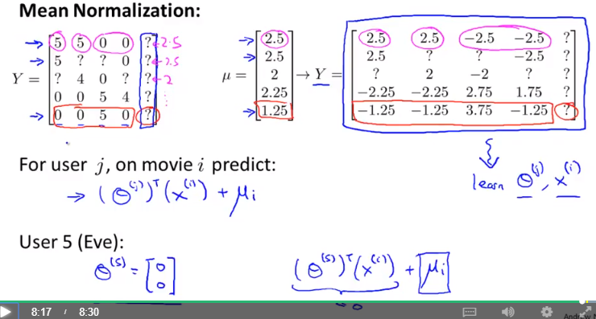

**Dealing with very large data sets**

Say for ex. If the data set contains 100 Million records, computation is going to take lot of time. Then in such scenario it is more meaningful to take a small sample say around 1000 records and check how the algorithm behaves with it, before jumping onto large data set.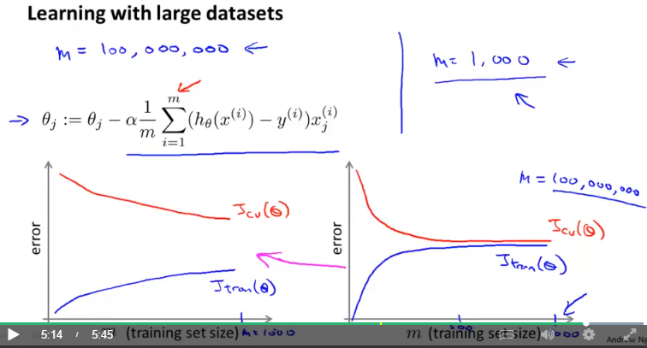

If the graph for n. Of samples to error is like the one shown on left, then it indicates that it has high variance and increasing number of samples to full data set will solve the problem. But if the graph is similar to one shown on right, it indicates that it is high bias algorithm and increasing dataset will not solve the problem and hence we can either increase the number of feature or correct the algorithm first and then check with larger data set.

Batch gradient descent can be very time consuming approach for large data set so alternate method is to use stochastic gradient descent

Difference between 2 gradient descent methods.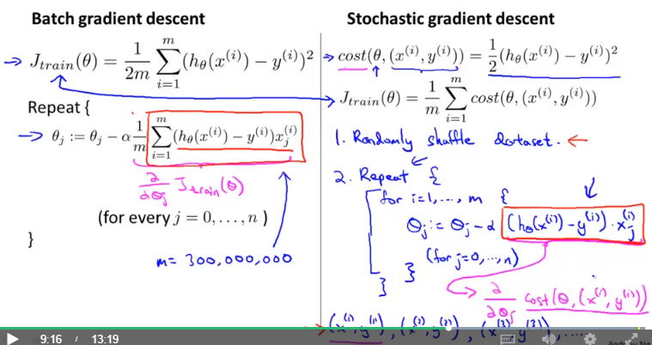

With stochastic gradient descent it may not converge directly but it may take multiple wrong steps. And it may not converge to global minimum and chances are there that it may keep cycling. But it will remain in affordable limits and that is fine for the algorithm.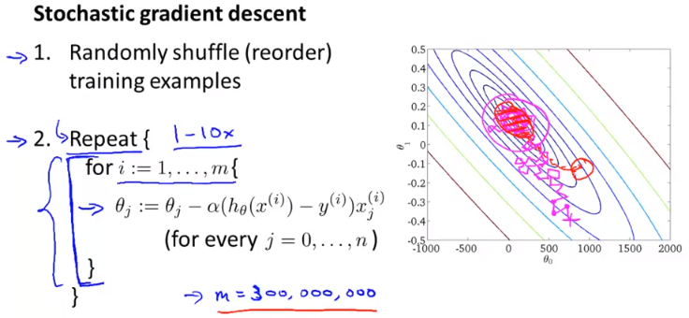

In batch gradient descent, the formula says it has to sum the derivative for each sample to calculate next step of the theta params. But if no. of samples are 300 million then all 300 million values need to be remembered as well as there is lot of calculations. So Stochastic Gradient descent will fit better for larger data sets.

**Mini Batch Gradient Descent**

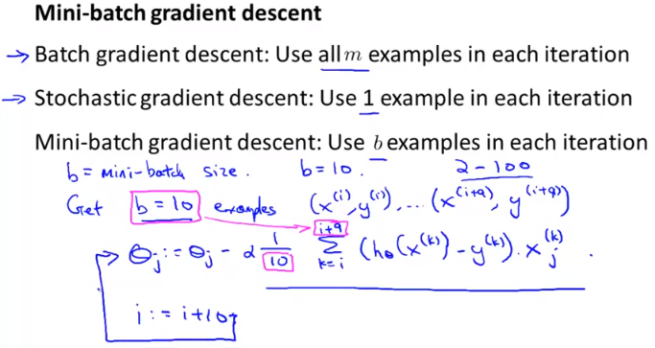

The advantage of this method is that just by scanning first 10 examples, algorithm will start updating the parameters. It need not wait till completing the scanning of whole data set could be millions of records. Another advantage of mini batch over Stochastic gradient descent is that it can scan 10 examples at a time so vectorization is possible but stochastic there is only 1 example at a time so it has to follow iterative process. Ususally batch size can vary from 2 to 100. Most of the time 10 is a good choice

**Convergence for all gradient descent**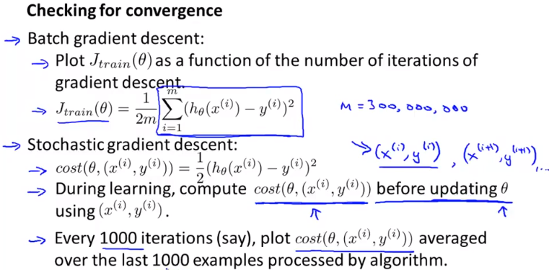

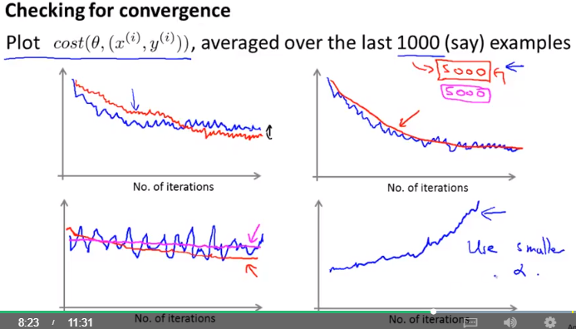

Average over larger samples set is shown here in the graph in various conditions.

**Online Learning** 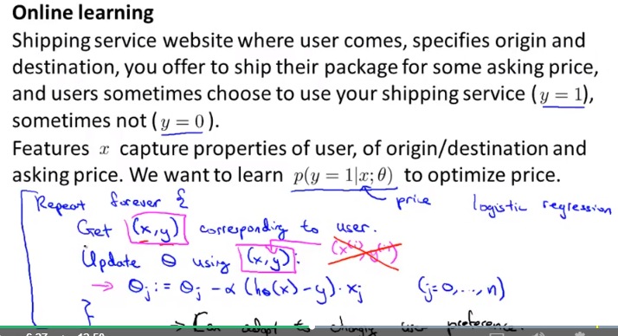

Online learning is perfectly suitable for cases where we want to learn whether the user will buy service from you online or not. In this method every single training example which keeps coming newly (after user made selection), will be used for training. Since there is only 1 example, it is like a stochastic gradient descent. This method can adapt to changing trends of the market (say a model becomes outdated or market becomes price conscious or similar). In such scnearios, it will get lot of examples with y = 0 and accordingly model will get updated.

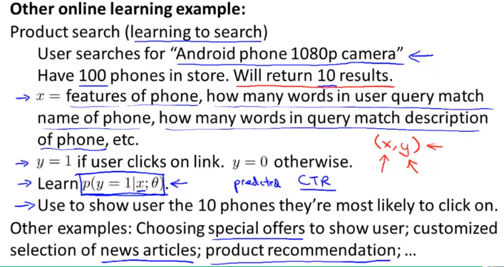

For each of the 10 shown results, we get a feature vector (a pair of feature vector and user’s choice y i.e. clicked on it or not) and the same can be used to make the algorithm learn.

**Map Reduce and data parallelism**

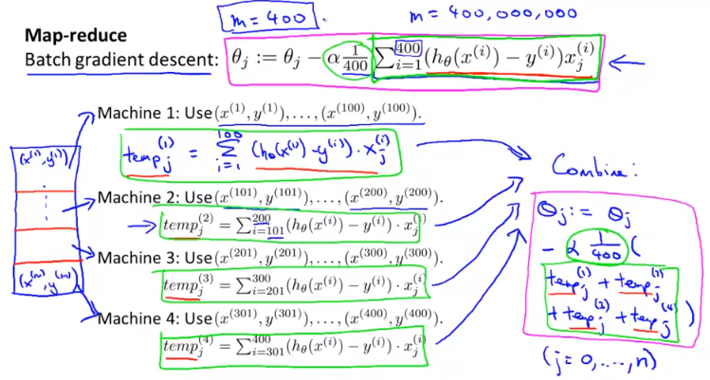

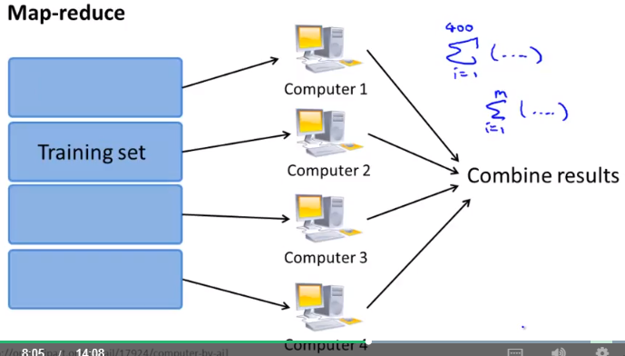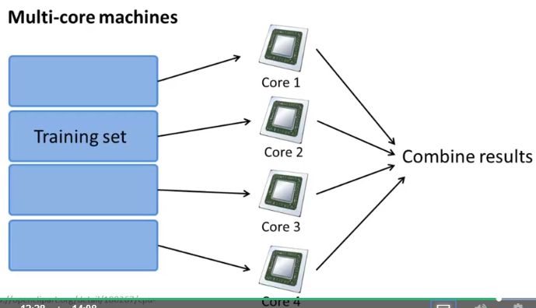

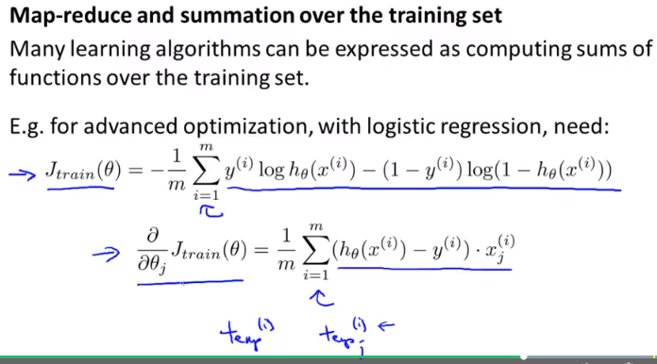

**Photo OCR Application**

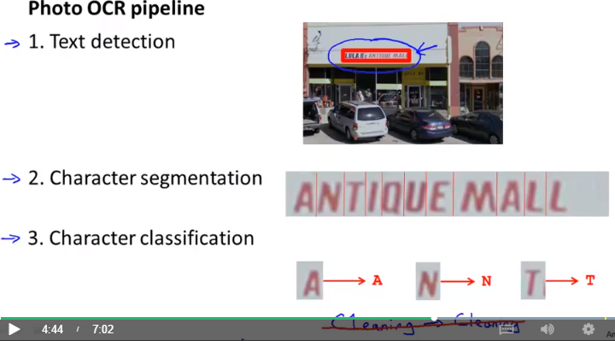

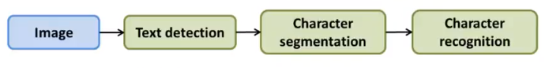

Generally all these applications are done through a pipeline which consists of number of tasks. Usually some of these tasks are machine learning tasks. Let’s take the example of text detection from the image. This requires above mentioned pipeline.

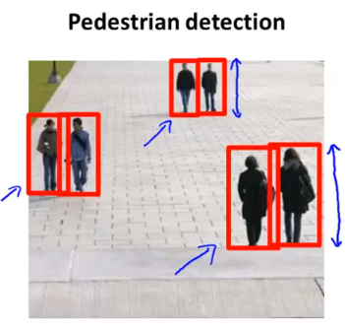

One of the application is pedestrian detection in which the aim is to scan the image and find is there is any pedestrian or not. This can be done by having a sliding window which moves from top left corner to bottom right corner in each step where each step is separated by a distance called step size or the stride. If the pedestrian is far from the camera then the window size required is small but if the pedestrian is nearby then the window size required is large. For this we may change the window size iteratively and check for pedestrians

The first step of the pipeline would be to train a supervised learning model using logistic regression or neural network with labelled data set having positive and negative cases. Once it is trained, we can pass in the image data for each window and ask algorithm to predict whether there is any pedestrian or not. This will be done for different sizes of windows. At the end we will be able to detect all the pedestrians.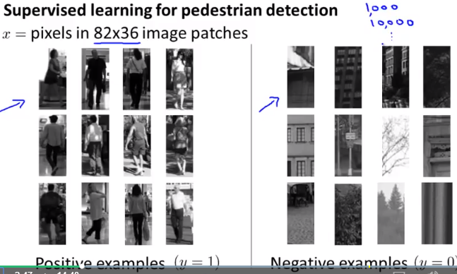

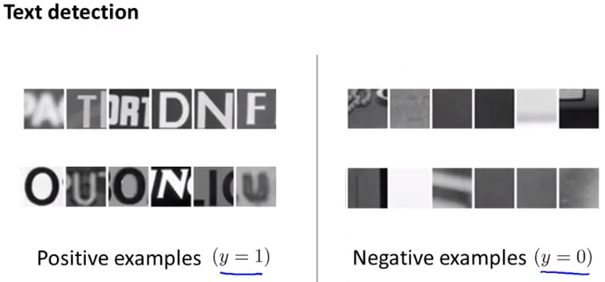

Similarly for text detection application, first step in the pipeline would be to detect if is any area which corresponds to text? For this we will train a model with lot of images having characters. Then use this model to detect if the sliding window contains characters?

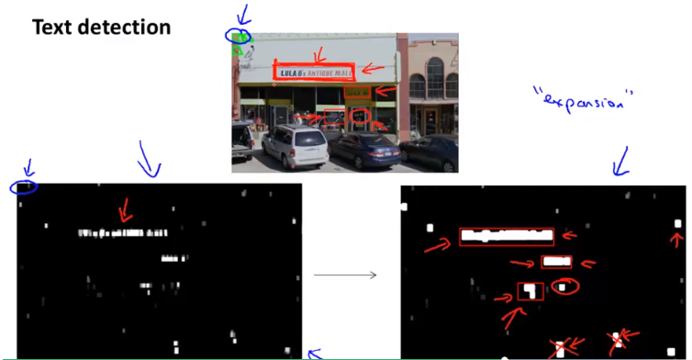

The main problem with text detection is we do not know the length of the string so deciding the window size is difficult. To solve this, we can keep window size somewhat similar to size of 1 character or even bit larger than that. Then run the sliding window to find if it has any characters or not. The lower left image shows the pixels for which classifiers returned true or false. Then a expansion is applied to it to get an image like bottom right. Mathematically implemented by checking for each pixel that is this pixel close to any other white pixel within a certain range? If so, we can creating bounding box to create a text region. If we look at the bottom 2 pixel regions, the aspect ratio (width to height) ratio is high and we can just neglect it for strings. The region marked in circle is a positive case but algorithm will not be able to find it.

Then the next step of the pipeline is character segmentation - finding the character gaps in the middle of the image. Even this can be implemented using the supervised learning by providing number of positive and negative samples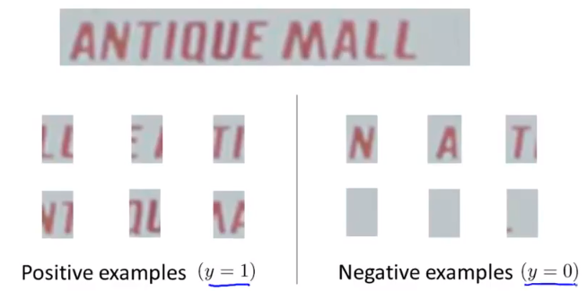

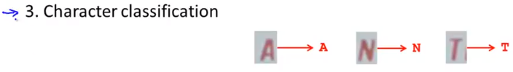

Then the next step is to apply classification to find the characters as we have seen it earlier.

**How to generate artificial data**

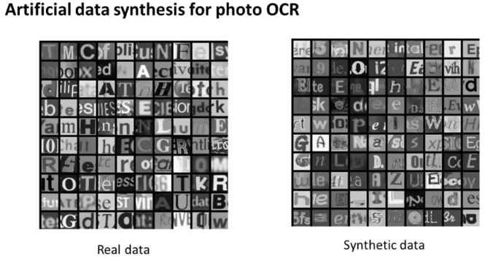

To create artificial data for character OCR, download various fonts from internet, copy the image of various letter (sometimes single letter, sometimes multiple letter in an image), paste it on a random background image. Apply blurring, scaling, rotating, distortion to create a synthetic data set. This is an example of generating data from scratch. Another approach of generating synthetic data is by applying the distortion. Similarly, by adding the background sounds to original audio signal we can get distorted audio files.Also we can add some distortion in terms of brightness or intensity of the pixels of image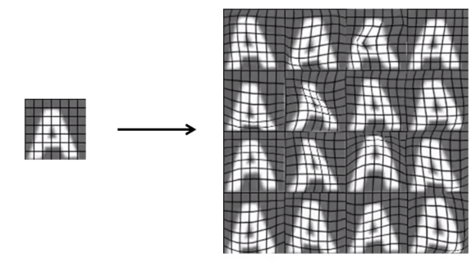

**Ceiling Analysis**

Let us assume that for the pipeline based machine learning application, the overall accuracy of the system was 72%. But this is the result of all the 3 systems in cascaded form. To identify which component requires more improvement, we can disable algorithm for each step (one by one) and instead manually provide the output identified by human and feed it to the next step in the pipeline and again run the same matrices to check the accuracy of the overall system. The %improvement in the system, can give you hint on working on which step of the pipeline is expected to improve the accuracy most. By looking at above analysis, we can say that improvising text detection step will increase the overall accuracy most. So we can concentrate our focus on that. Another example is as shown below.